|  |  |  |
| --- | --- | --- |
| **Lesson** | **Blockly Games and Code.org** | **Programming Concepts** |
| 1 | Activity and Blockly Games: Puzzle | Understanding Computer Science |
| 2 | Lesson 2: The Maze | Move, If/Else, Loops |
| 3 | Blockly Games: Maze | Move, If/Else, Loops |
| 4 | Blockly Games: Bird | Conditionals, If/else if/else, Angles |
| 5 | Lesson 5: The Artist | Loops, Move, Turn, Set Color |
| 6 | Lesson 7: The Artist 2 | Loops, Move, Turn, Set Color |
| 7 | Blockly Games: Turtle | Loops, Move, Turn, Set Color |
| 8 | Blockly Games: Movie | If/Else, Computational Thinking |
| 9 | Lesson 9: The Artist 3 |  |
| 10 | Lesson 13: The Farmer 2 | Functions |
| 11 | Lesson 15: The Artist 4 | Functions, Parameters |
| 12 |  |  |
| 13 |  |  |
| 14 |  |  |
| 15 |  |  |
| 16 |  |  |
| 17 |  |  |
|  |  |  |
|  |  |  |
|  |  |  |
|  |  |  |
|  |  |  |
|  |  |  |
|  |  |  |
|  |  |  |
|  |  |  |
|  |  |  |
|  |  |  |
|  |  |  |
|  |  |  |

**Blockly Games: Puzzle**

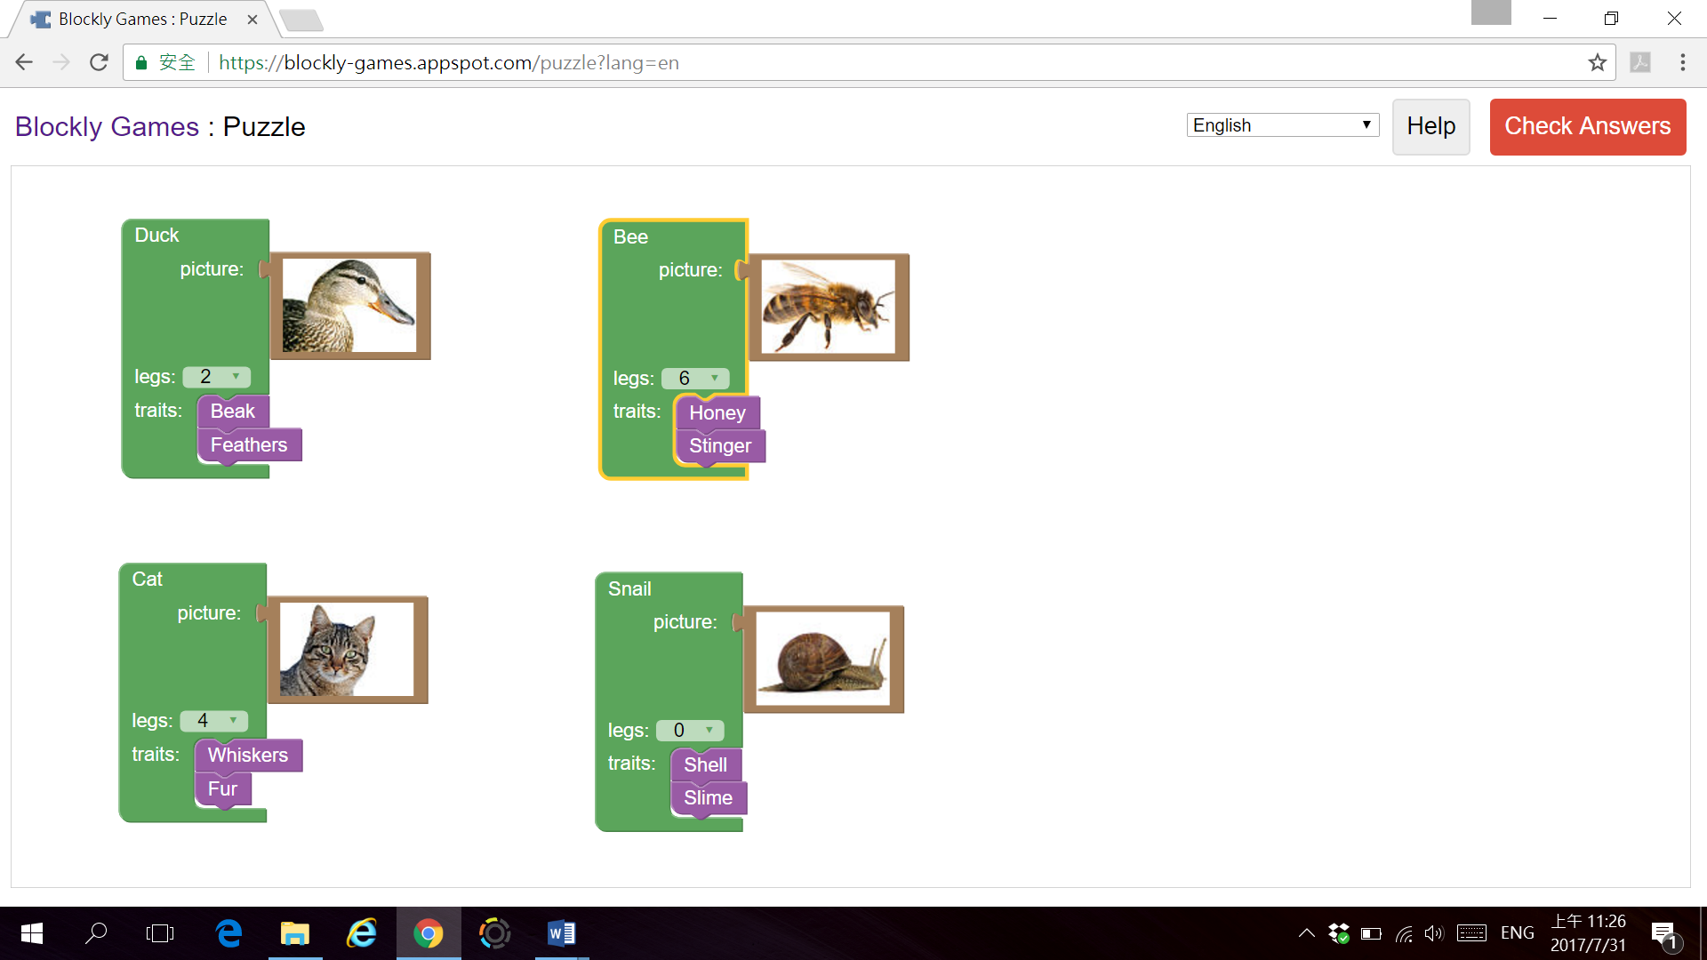

**Lesson 2: The Maze**

**Challenge 1**

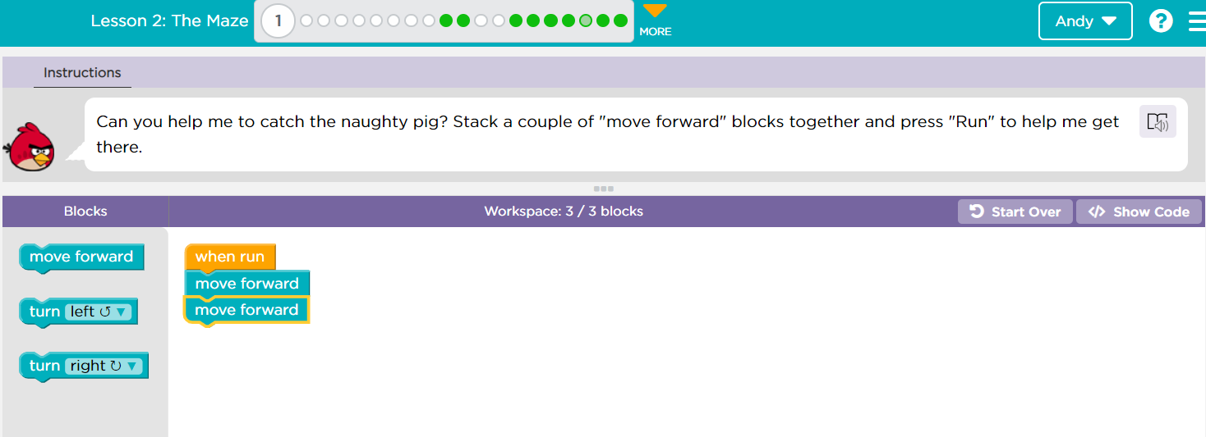

**Challenge 2**

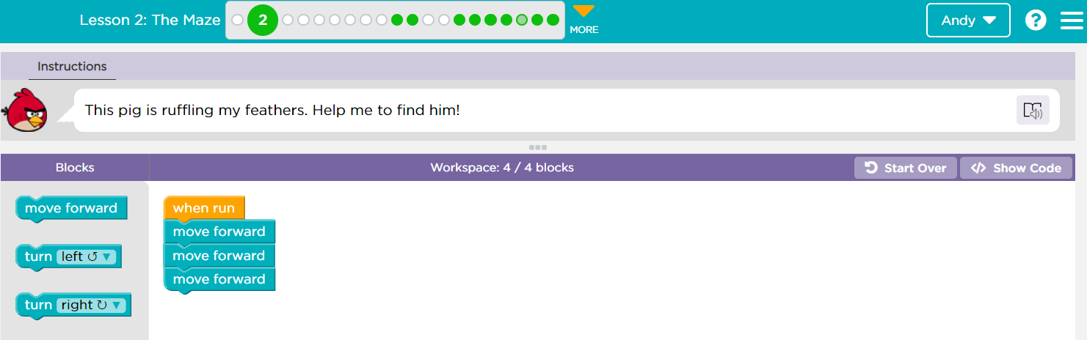

**Challenge 3**

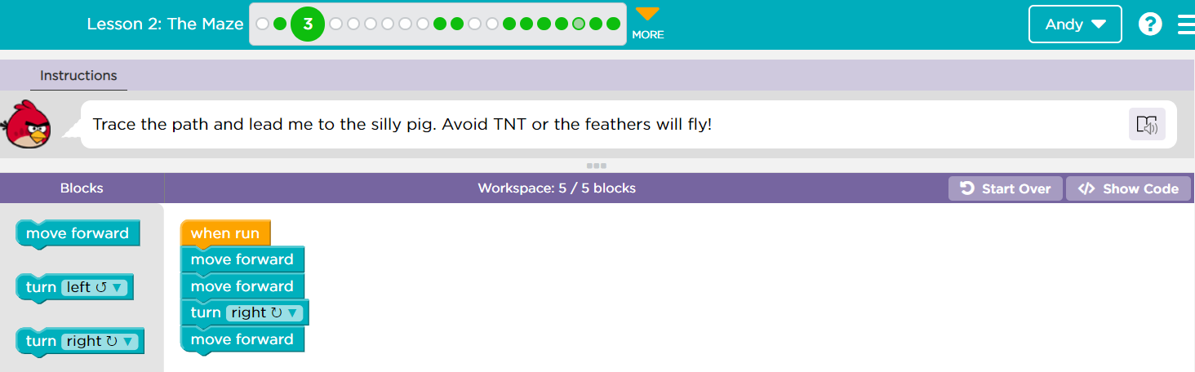

**Challenge 4**

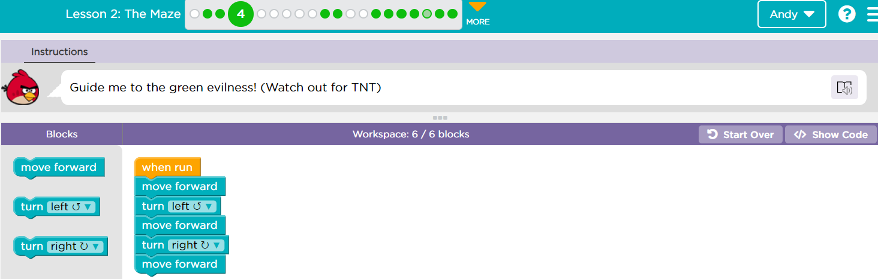

**Challenge 5 (stop after 5 and explain for loops)**

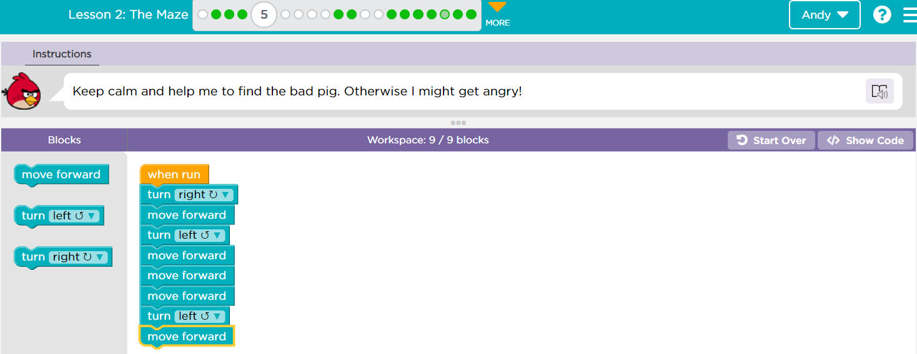

**Challenge 6**

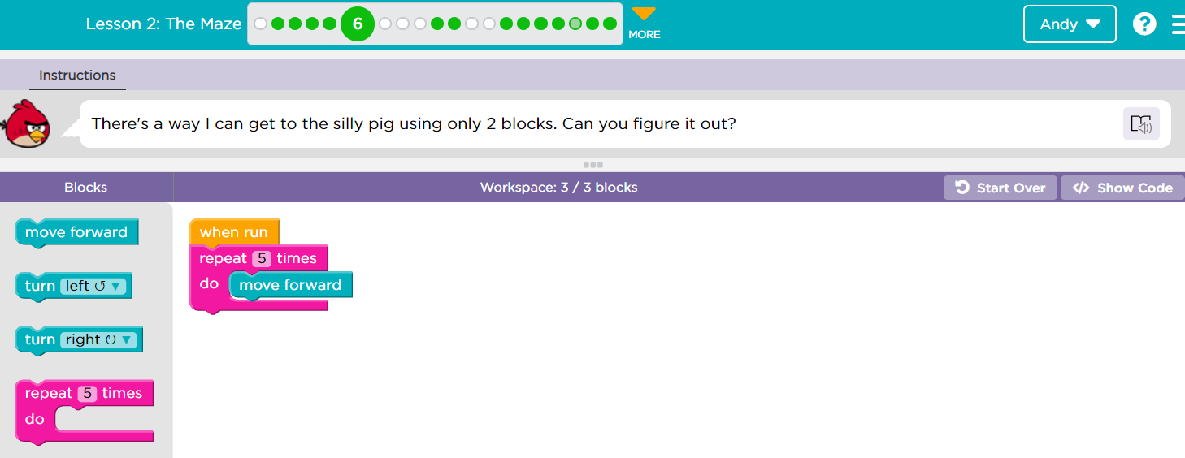

**Challenge 7**

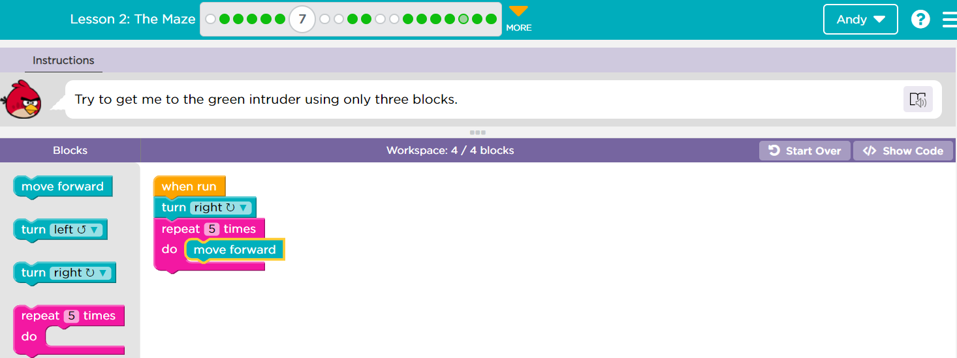

**Challenge 8**

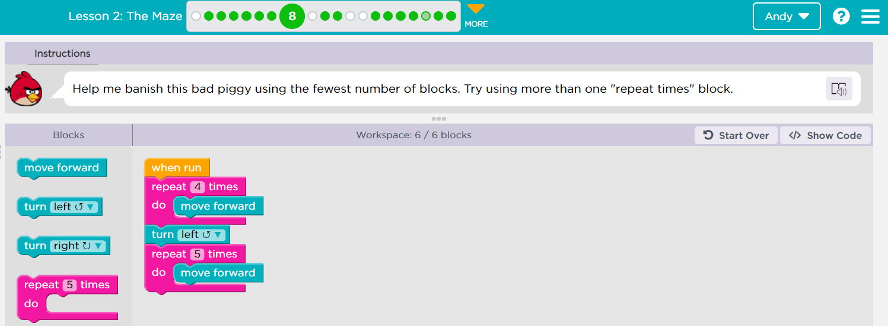

**Challenge 9 (stop after 9 and explain while loops)**

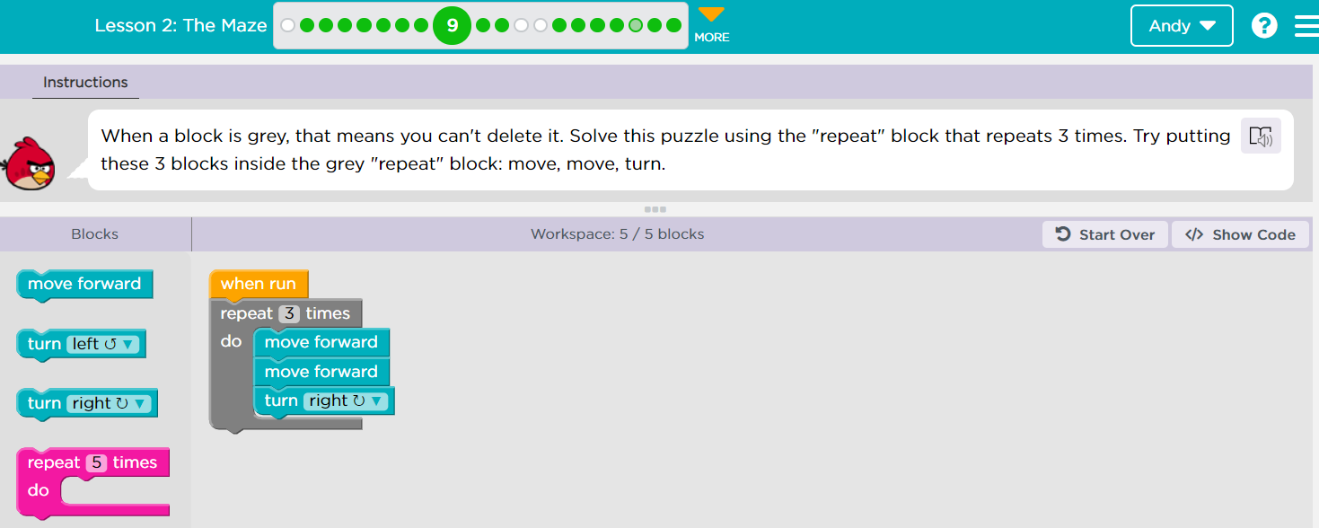

**Challenge 10**

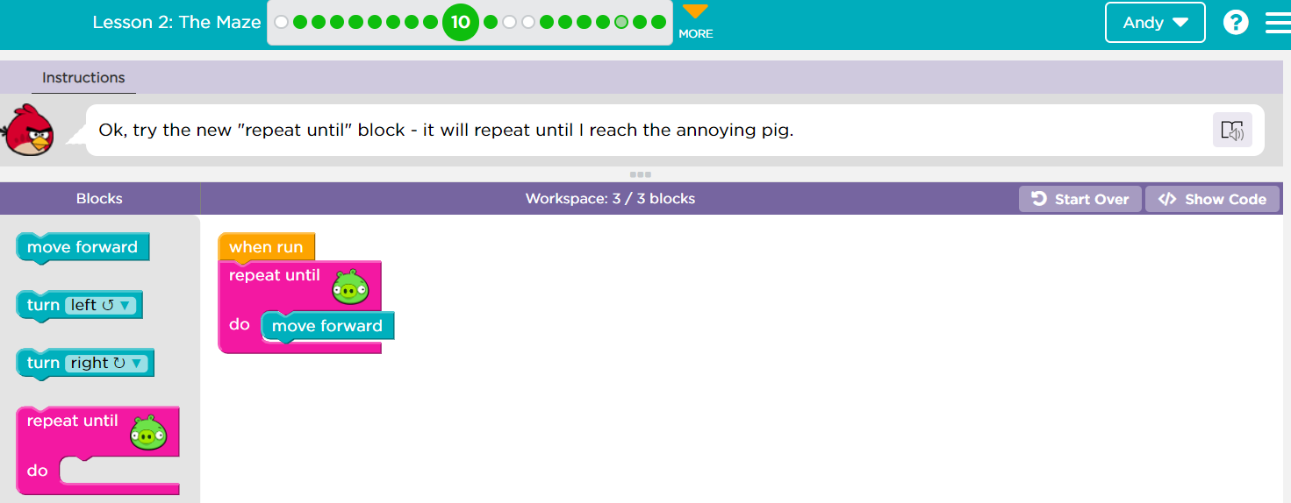

**Challenge 11**

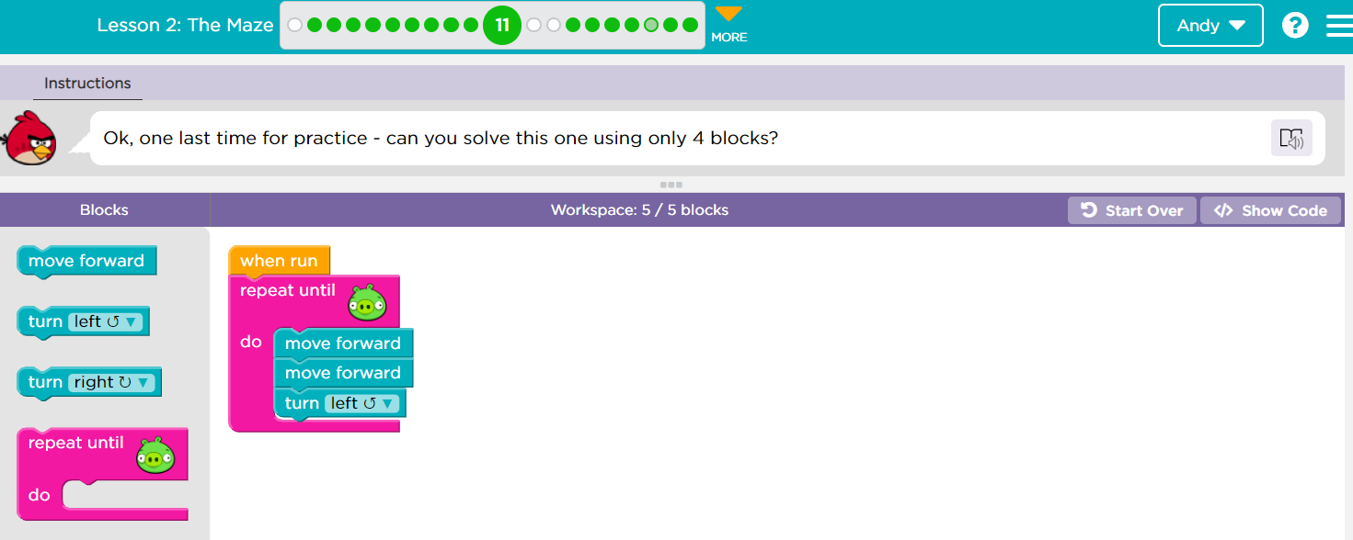

**Challenge 12**

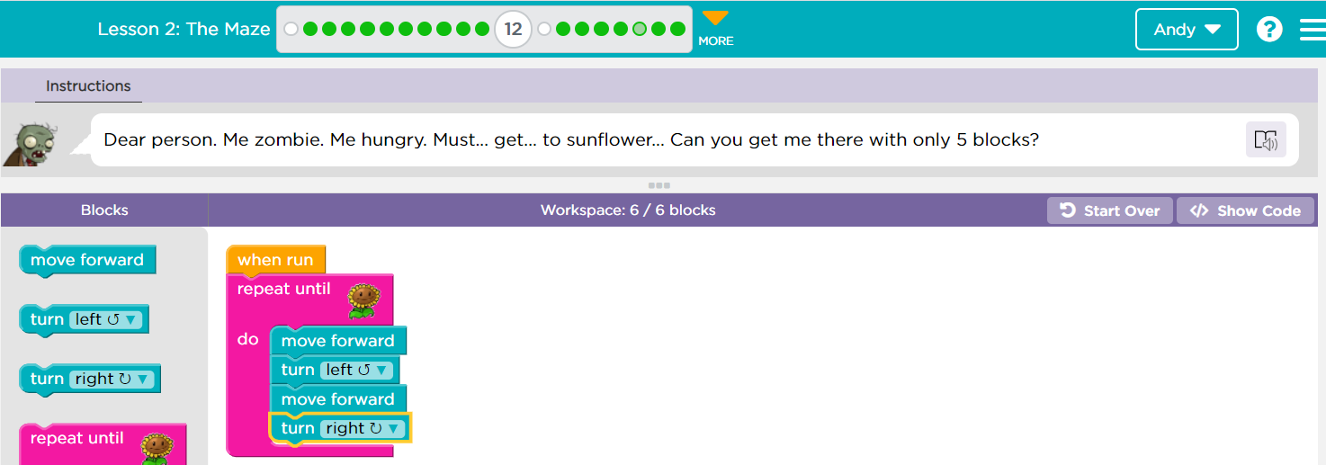

**Challenge 13 (after this stop and explain if)**

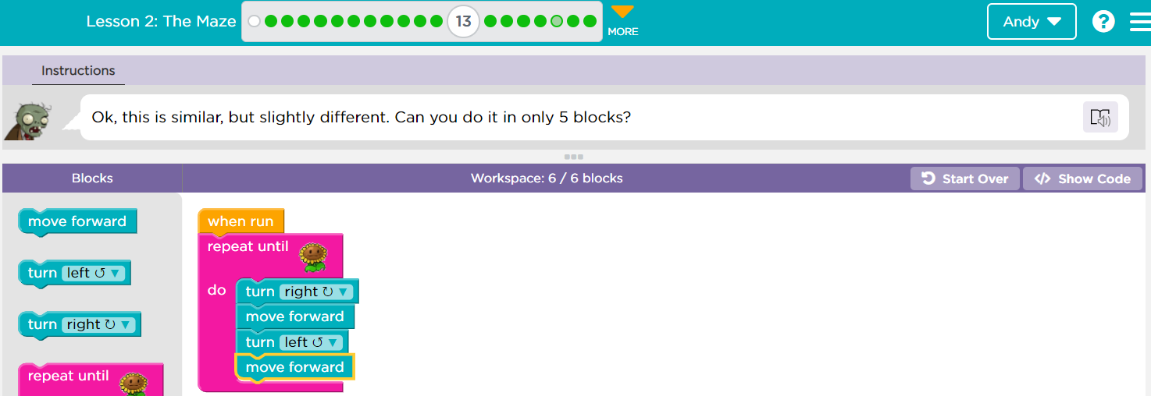

**Challenge 14**

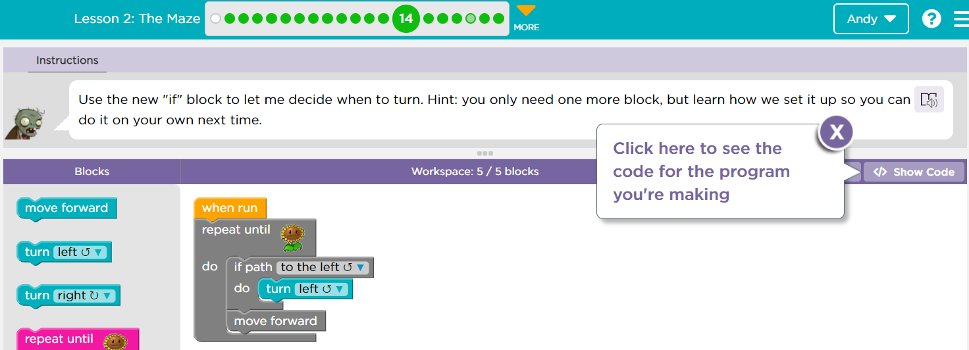

**Challenge 15**

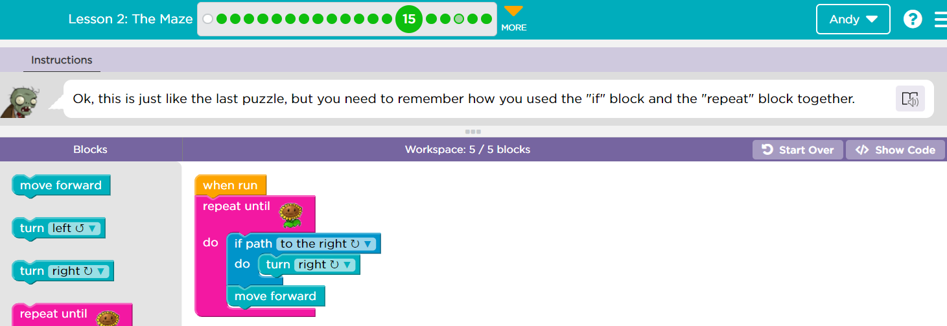

**Challenge 16 (after this stop to explain if else)**

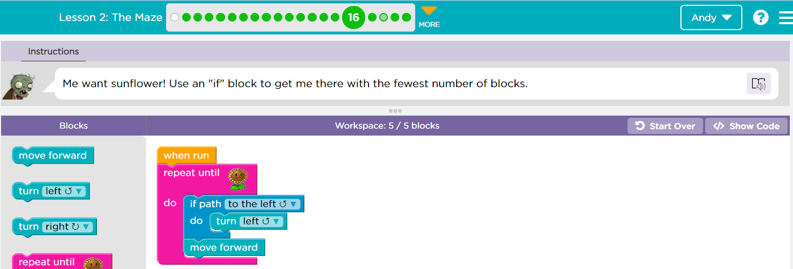

**Challenge 17**

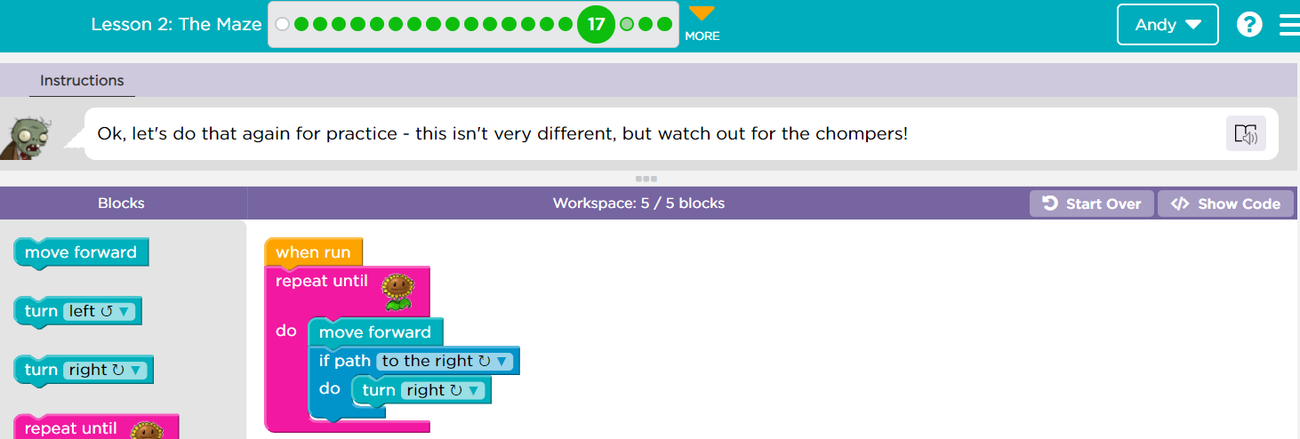

**Challenge 18**

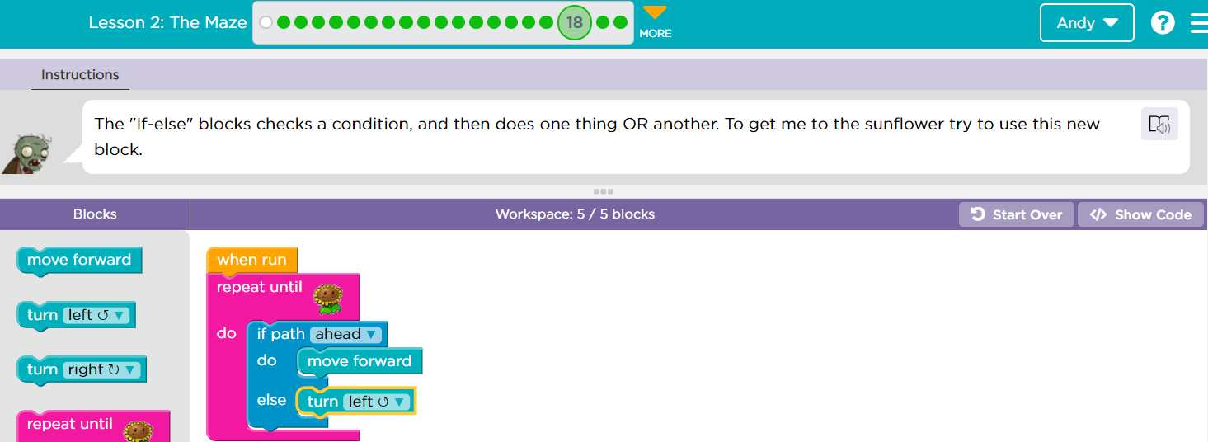

**Challenge 19**

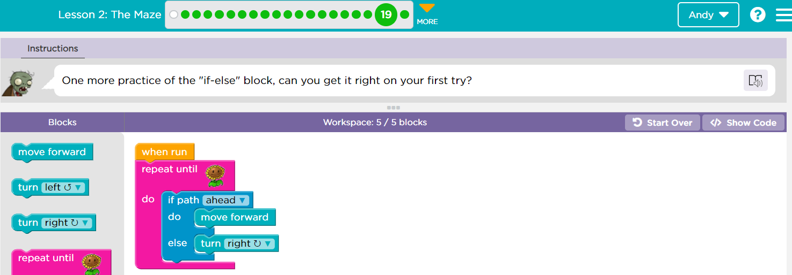

**Challenge 20**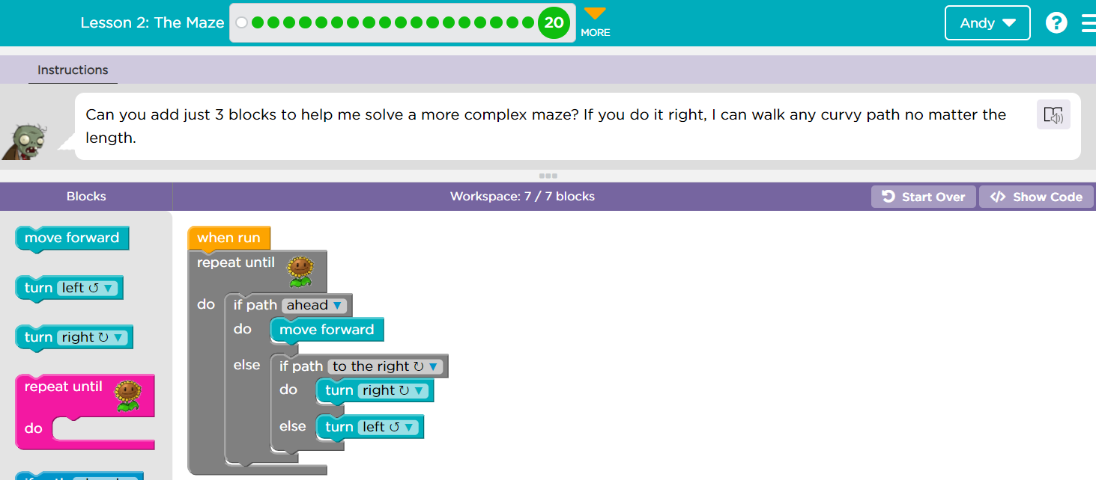

**Blockly Games: Maze**

**Challenge 1**

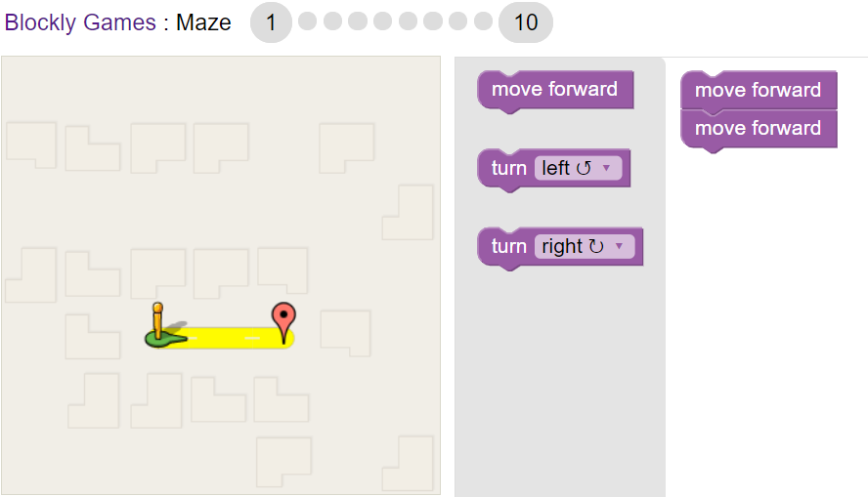

**Challenge 2**

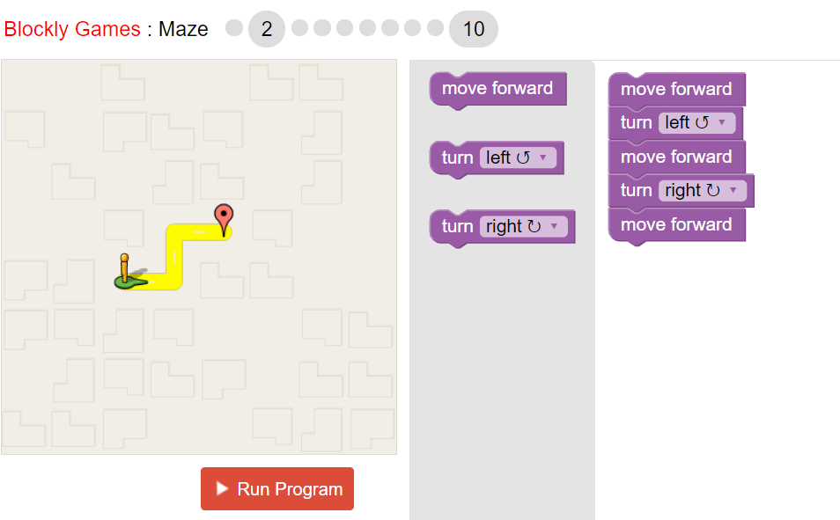

**Challenge 3**

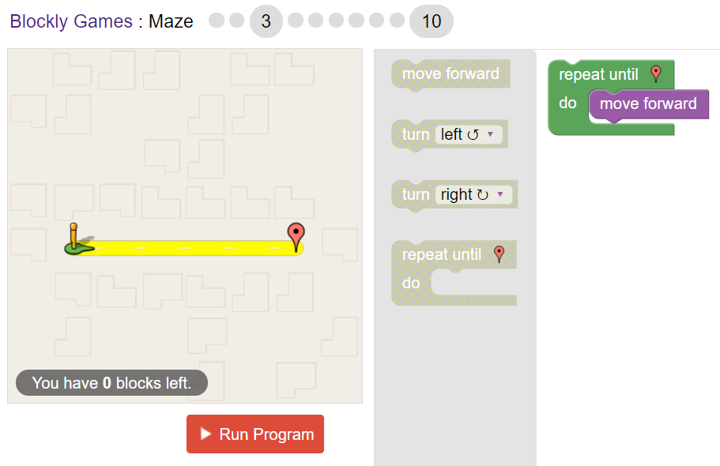

**Challenge 4**

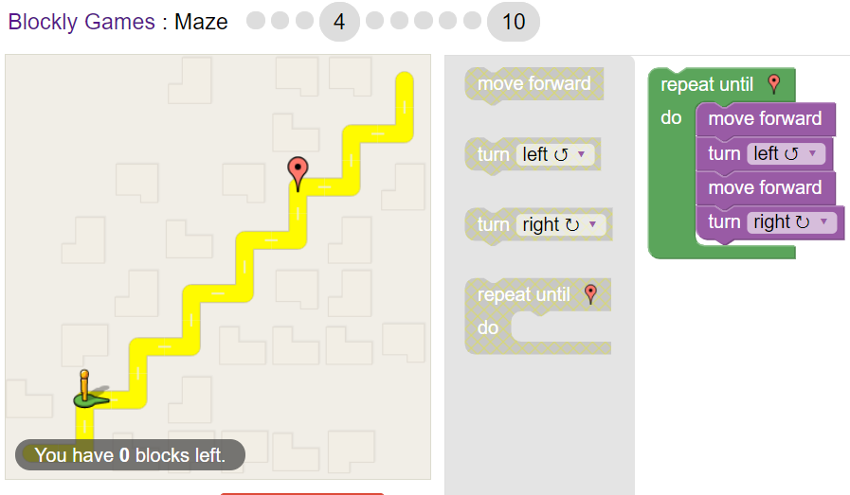

**Challenge 5**

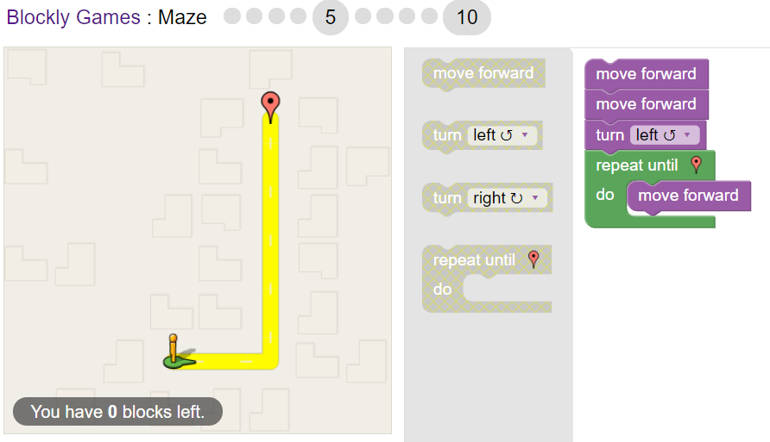

**Challenge 6**

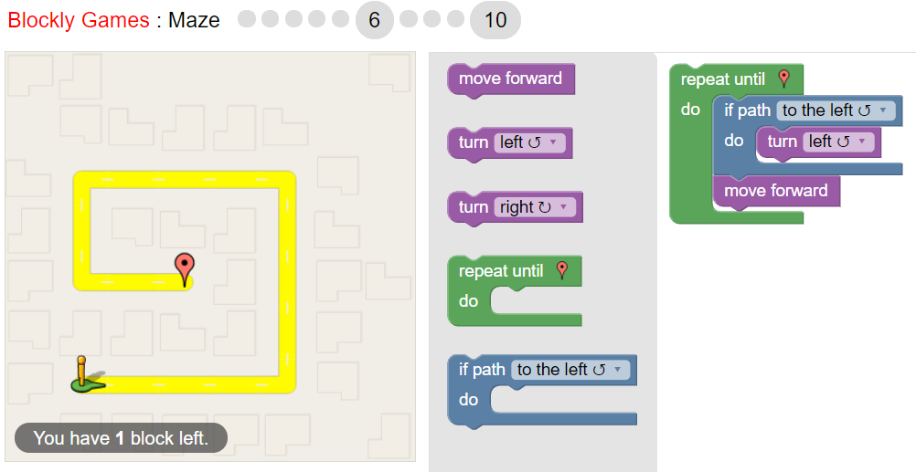

**Challenge 7**

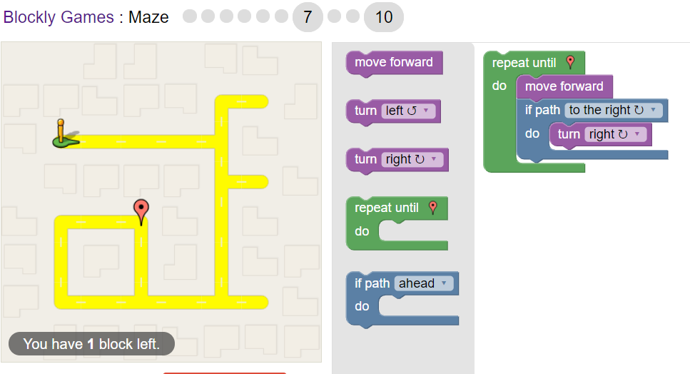

**Challenge 8**

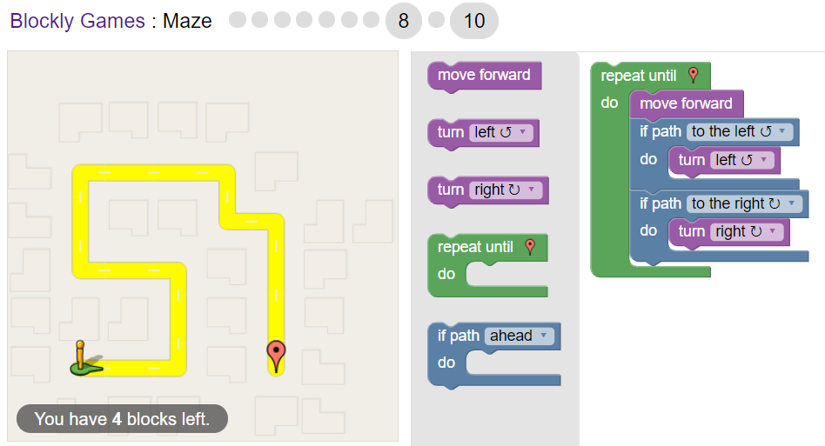

**Challenge 9**

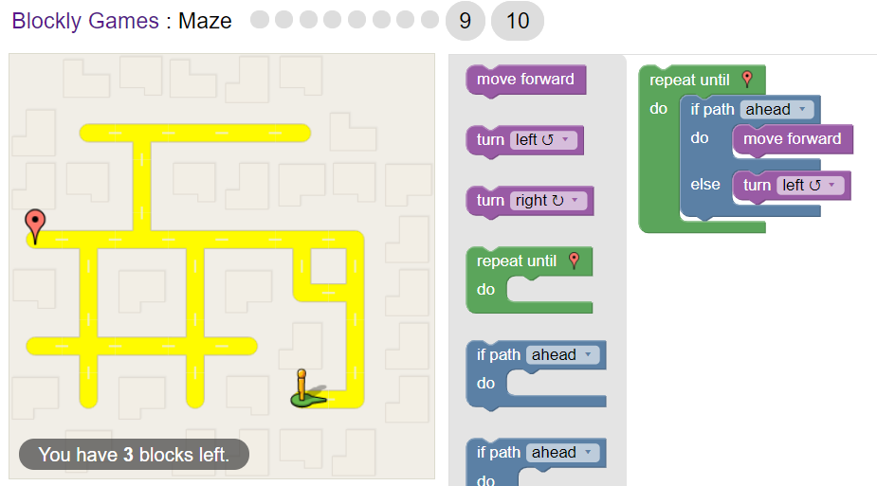

**Challenge 10**

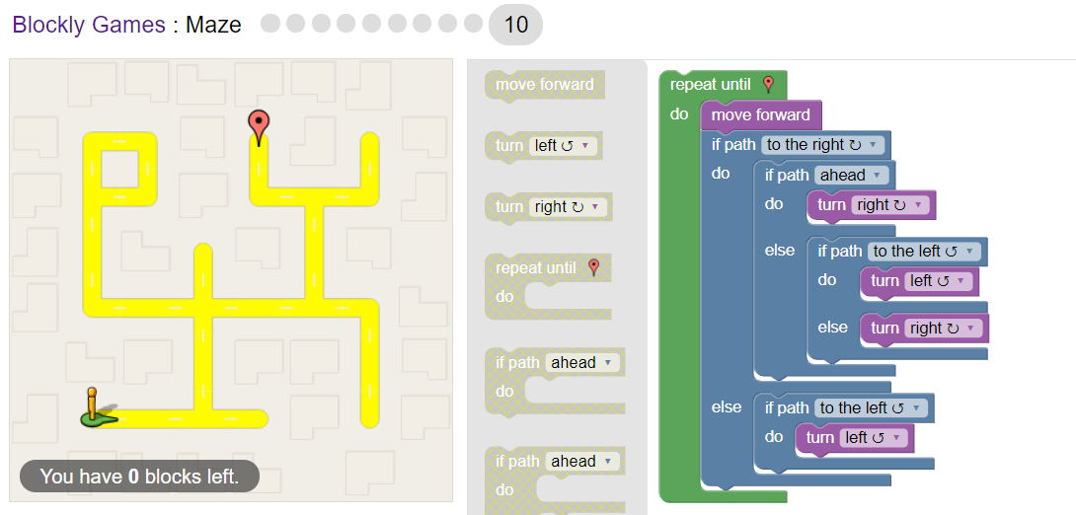

**Blockly Games: Bird**

**Challenge 1**

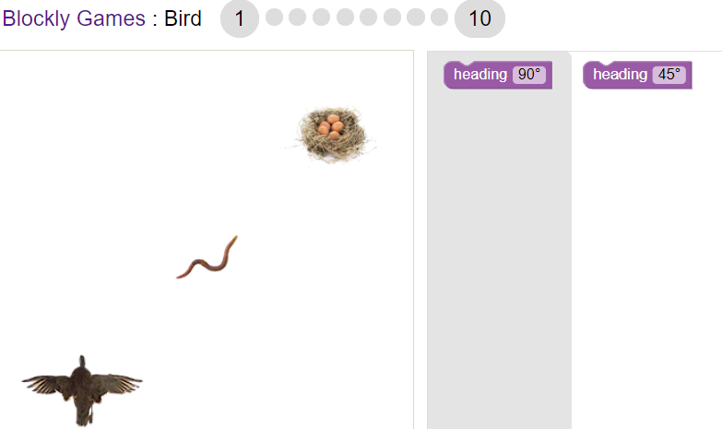

**Challenge 2**

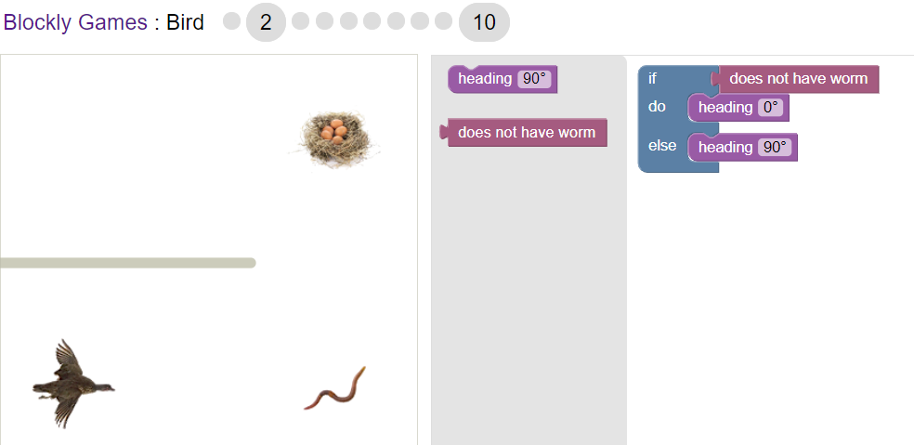

**Challenge 3**

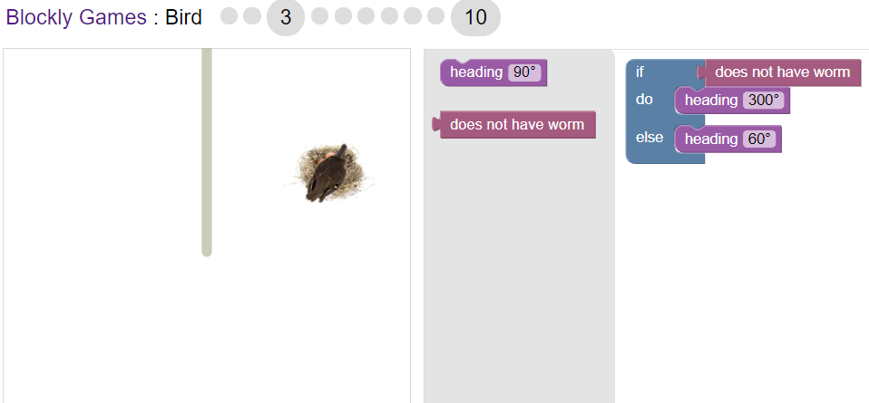

**Challenge 4**

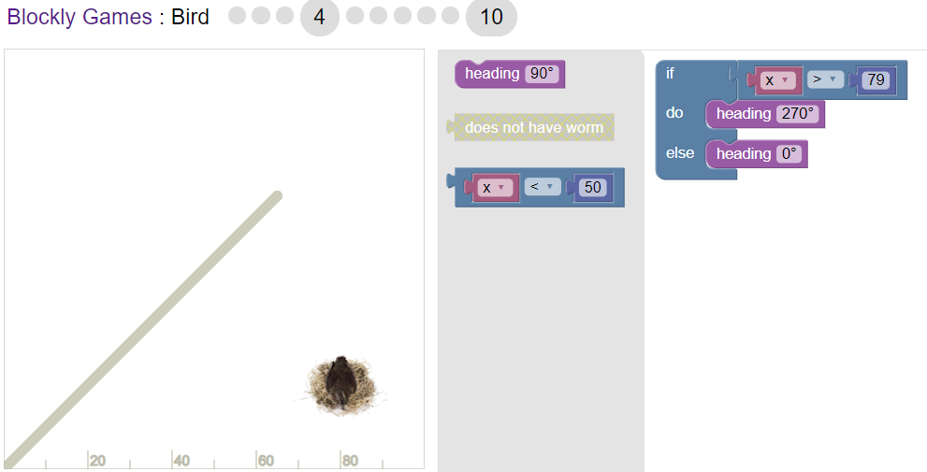

**Challenge 5**

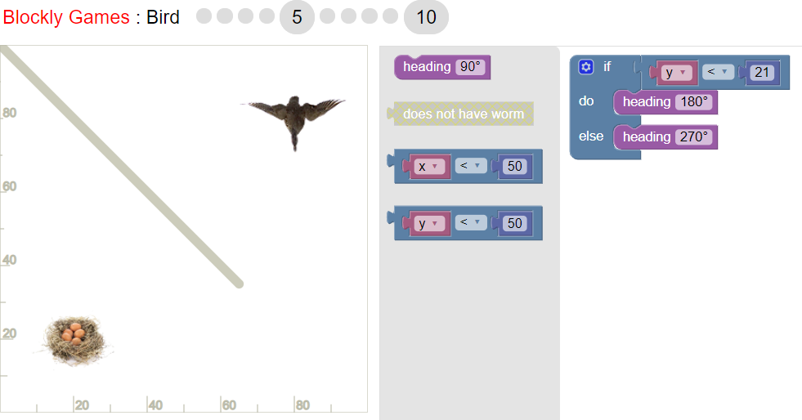

**Challenge 6**

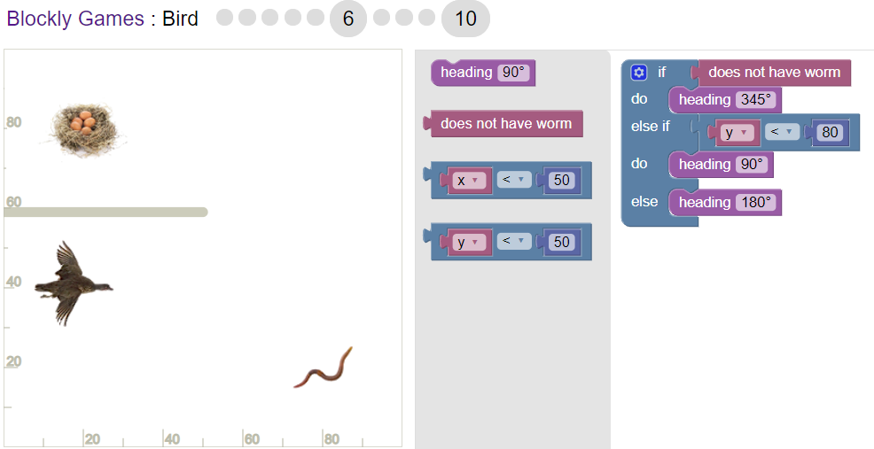

**Challenge 7 (stop after this and explain and)**

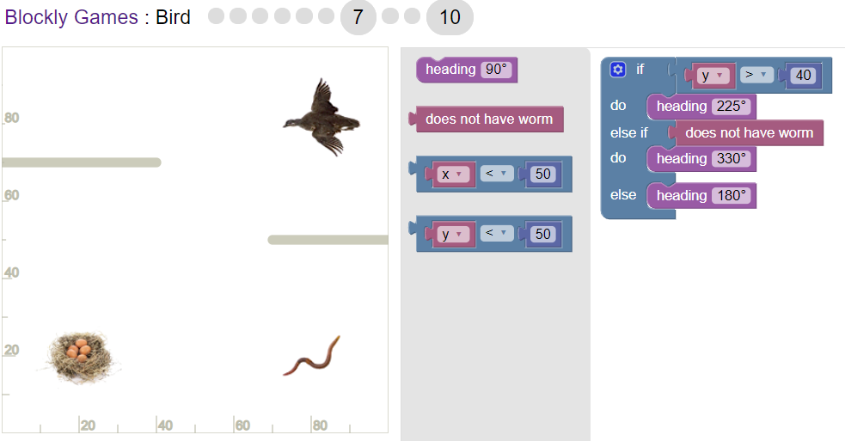

**Challenge 8**

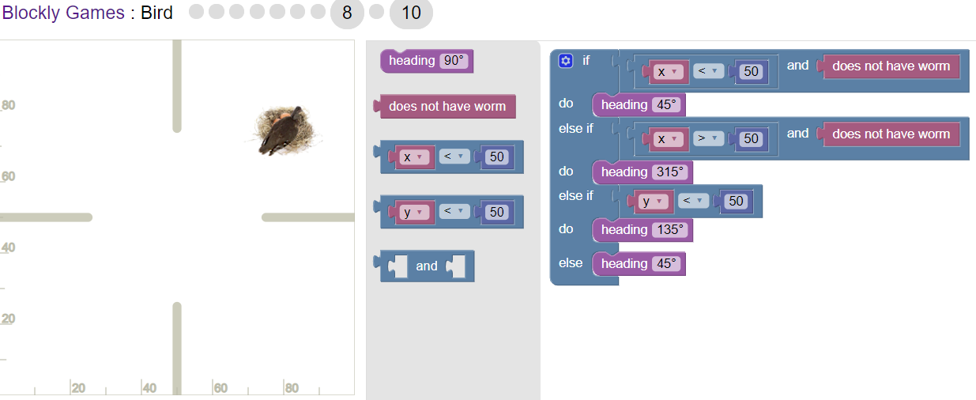

**Challenge 9**

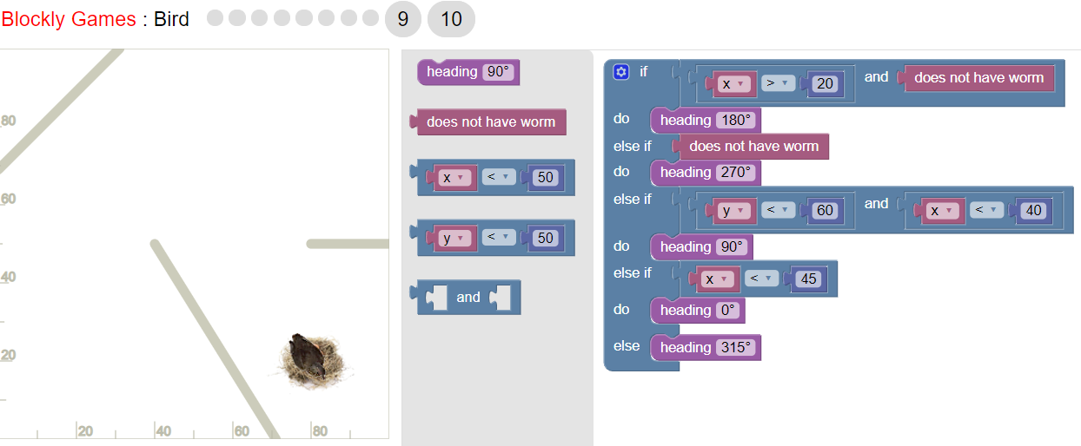

**Challenge 10**

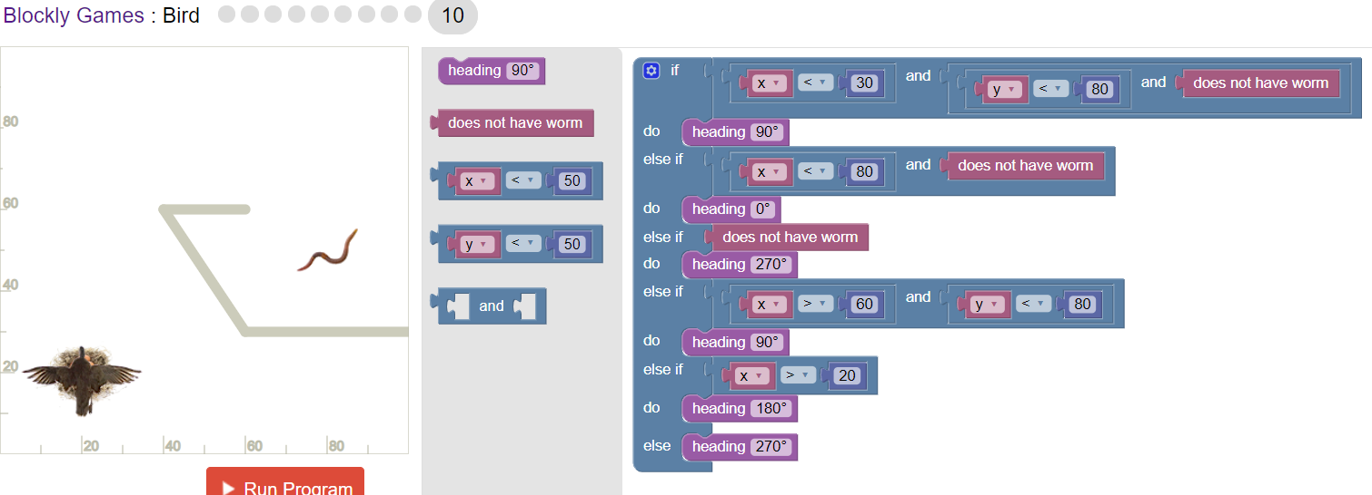

**Lesson 5: The Artist**

**Challenge 1**

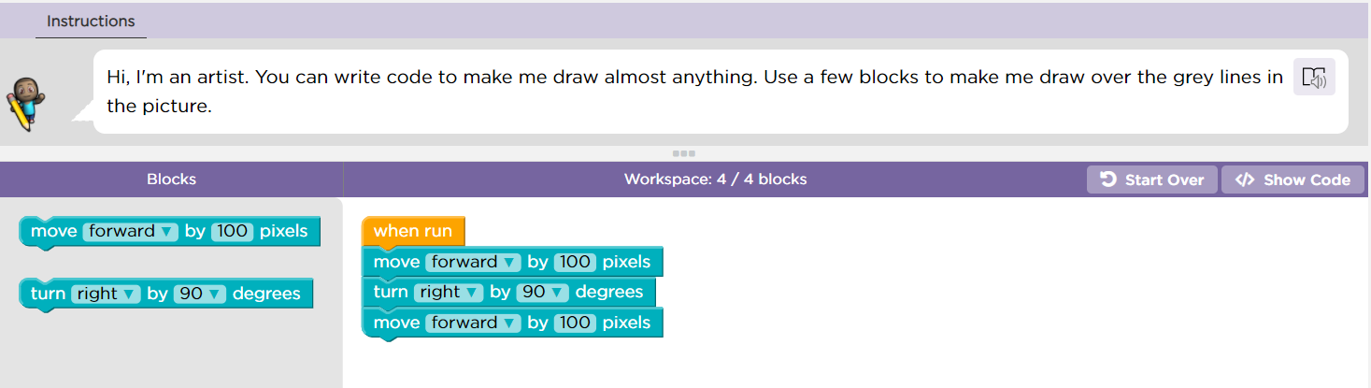

**Challenge 2**

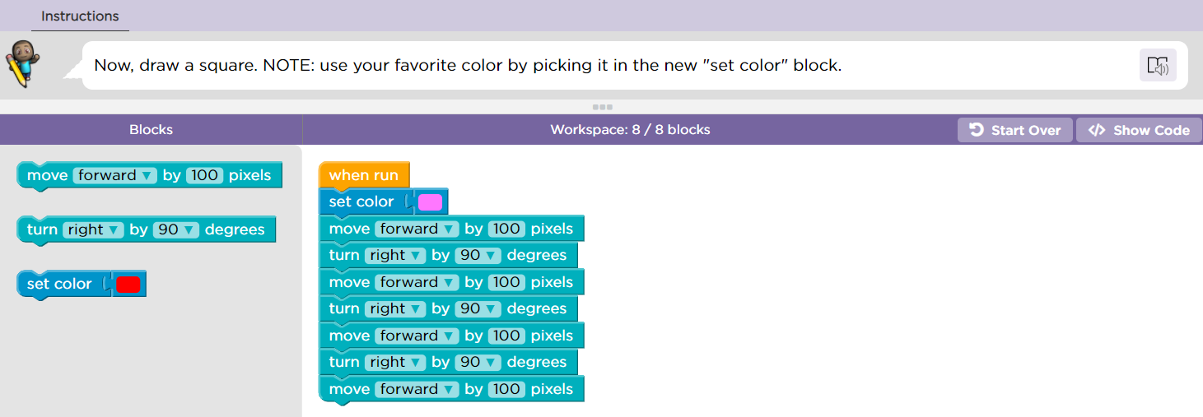

**Challenge 3**

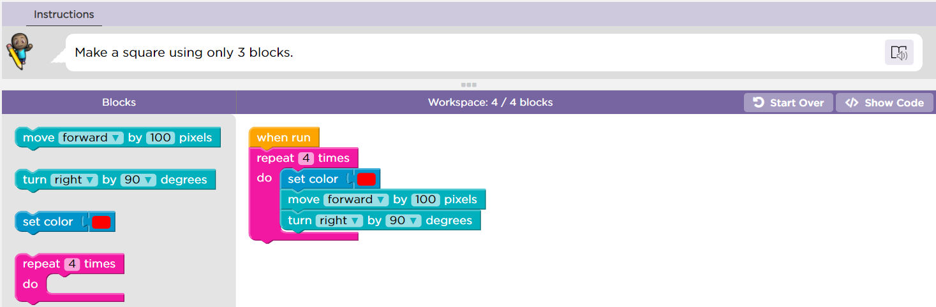

**Challenge 4**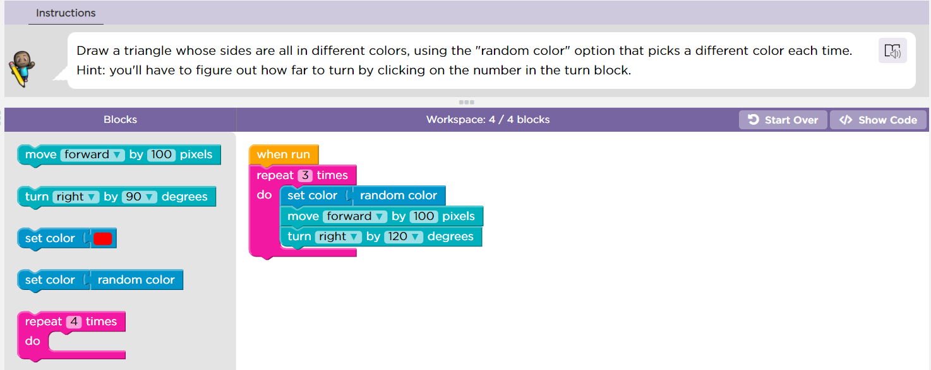

**Challenge 5**

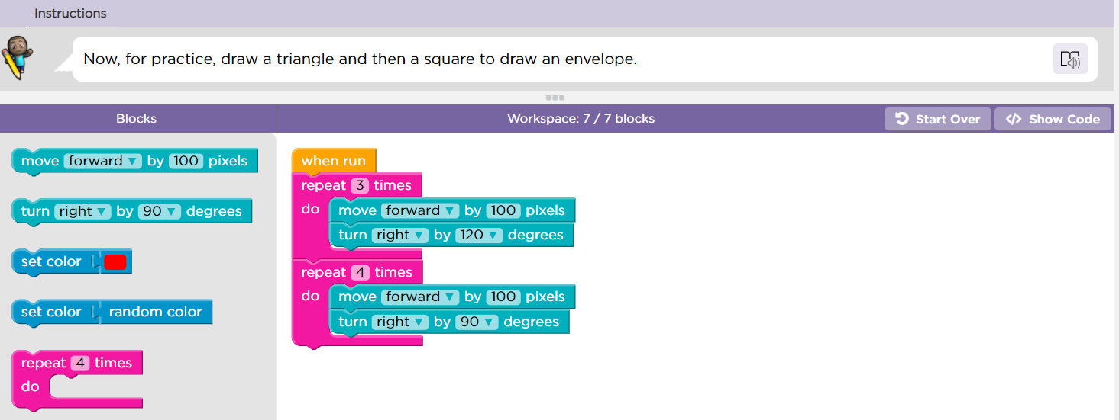

**Challenge 6**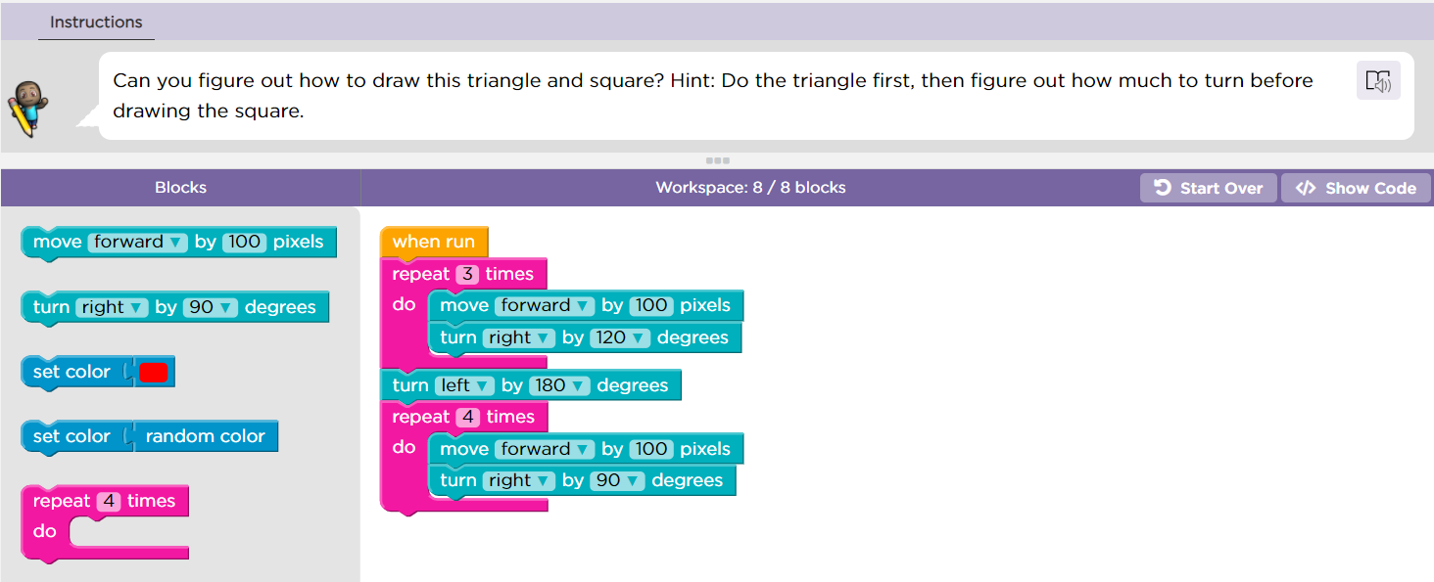

**Challenge 7**

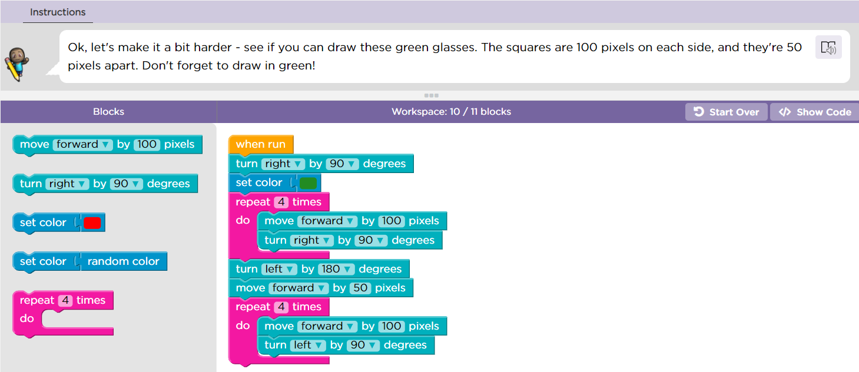

**Challenge 8**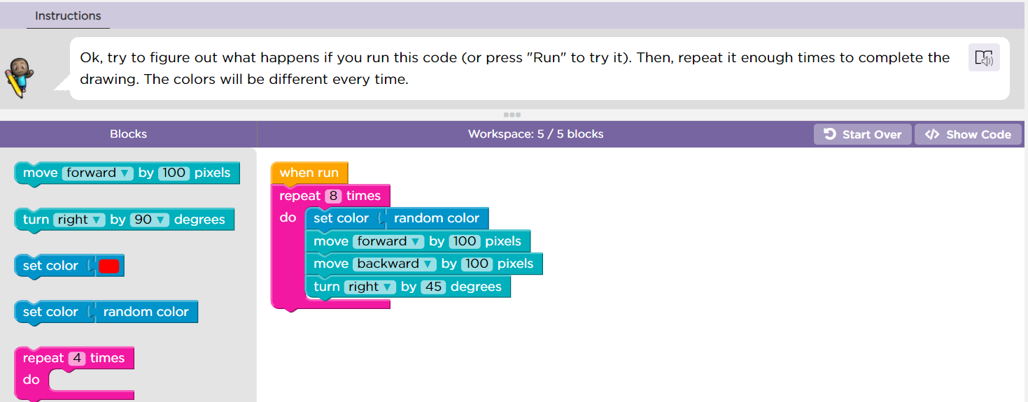

**Challenge 9**

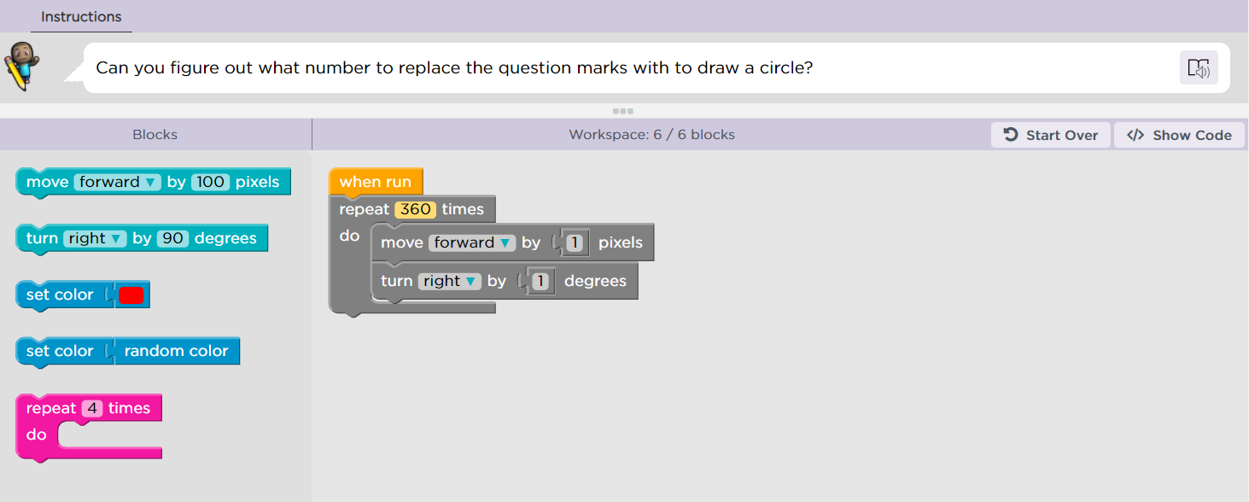

**Challenge 10: draw this** 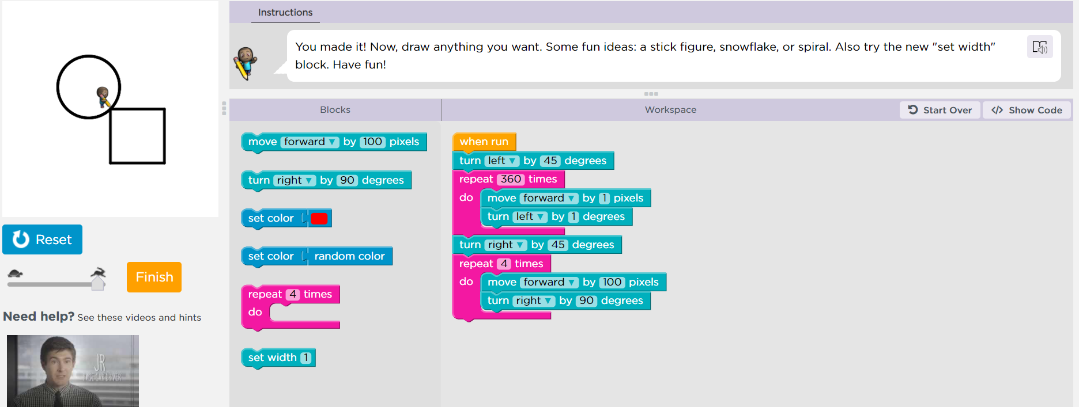

**Lesson 7: The Artist 2**

**Challenge 1**

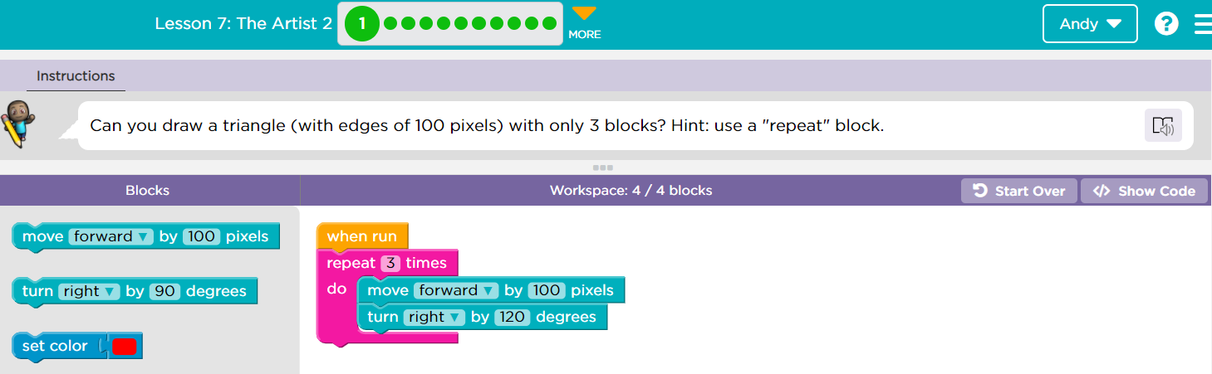

**Challenge 2**

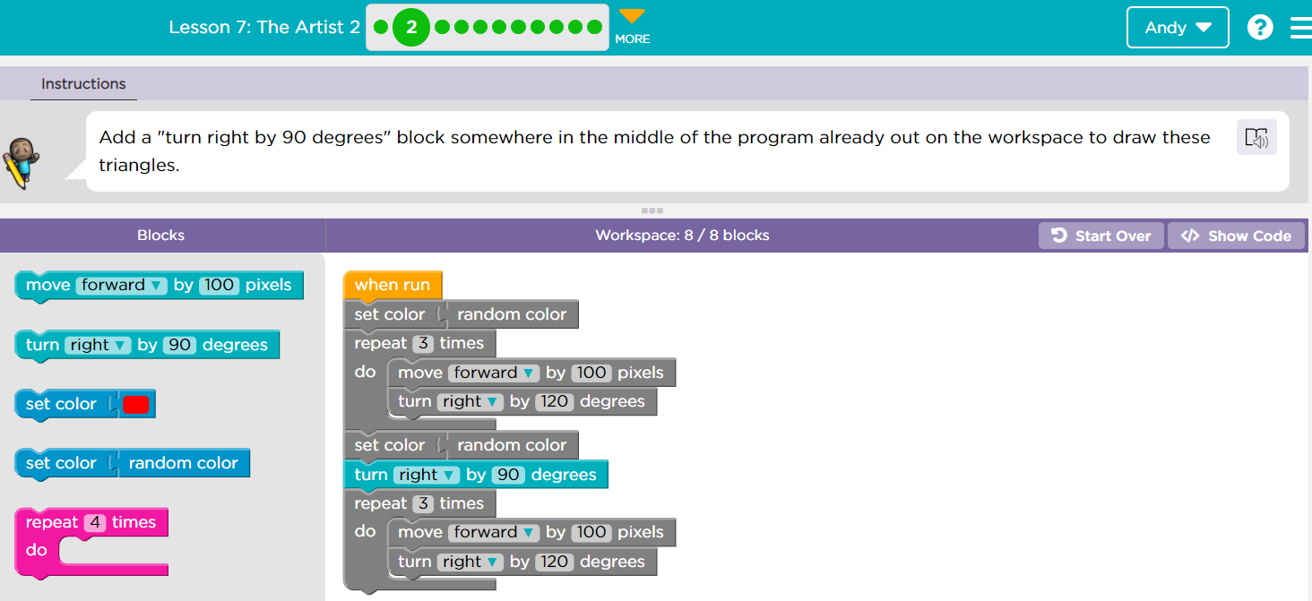

**Challenge 3**

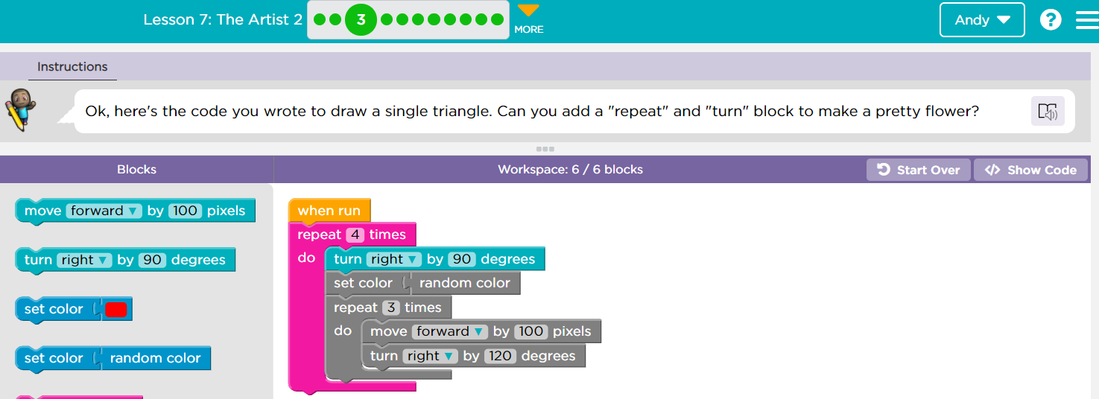

**Challenge 4**

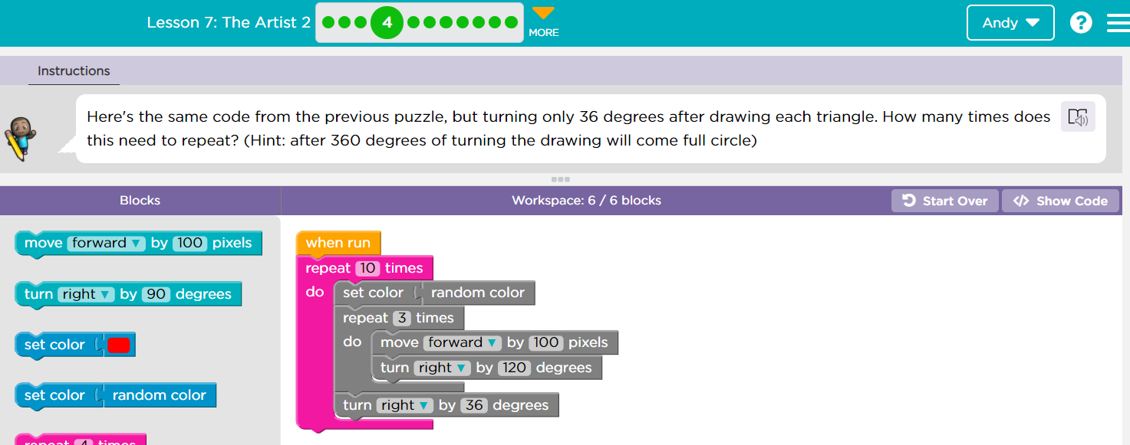

**Challenge 5**

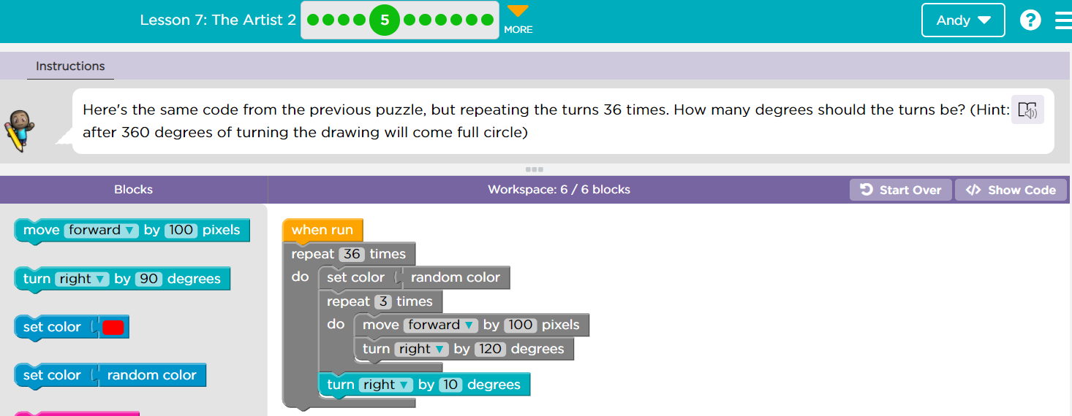

**Challenge 6**

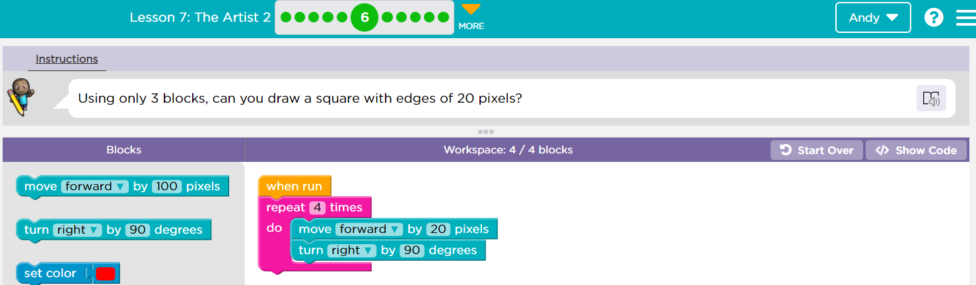

**Challenge 7**

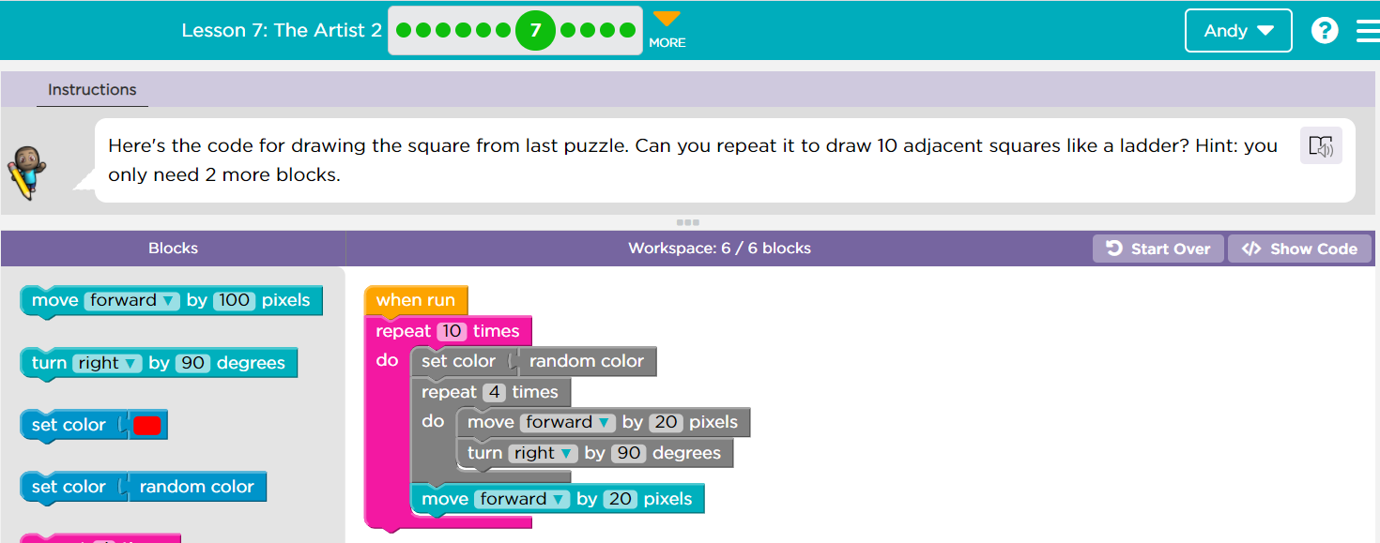

**Challenge 8**

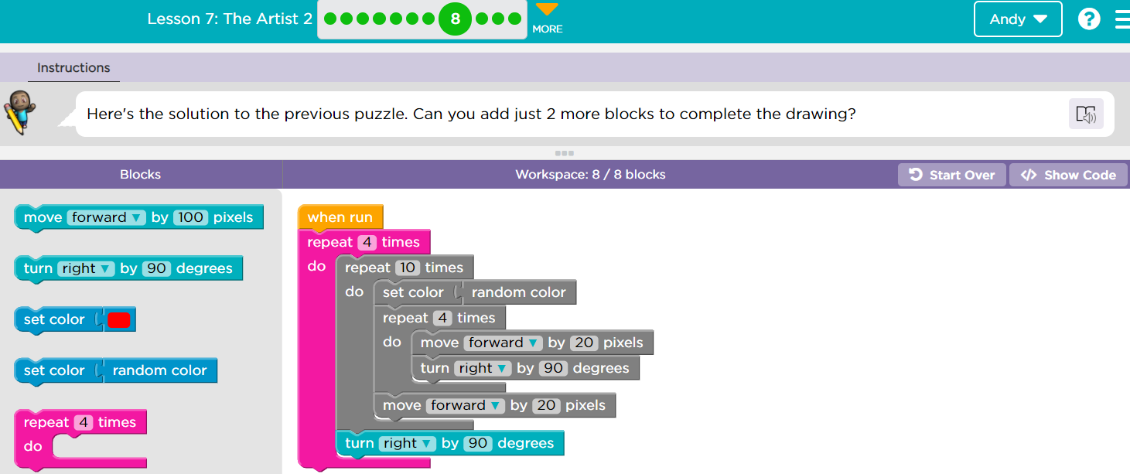

**Challenge 9**

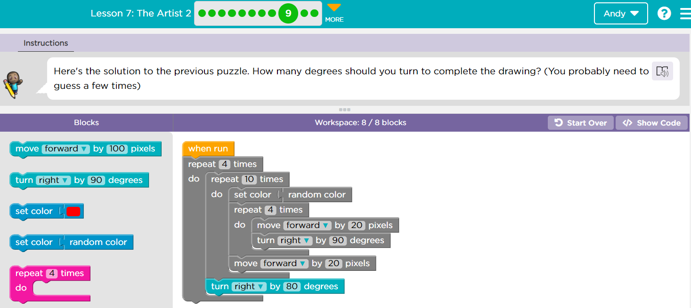

**Challenge 10**

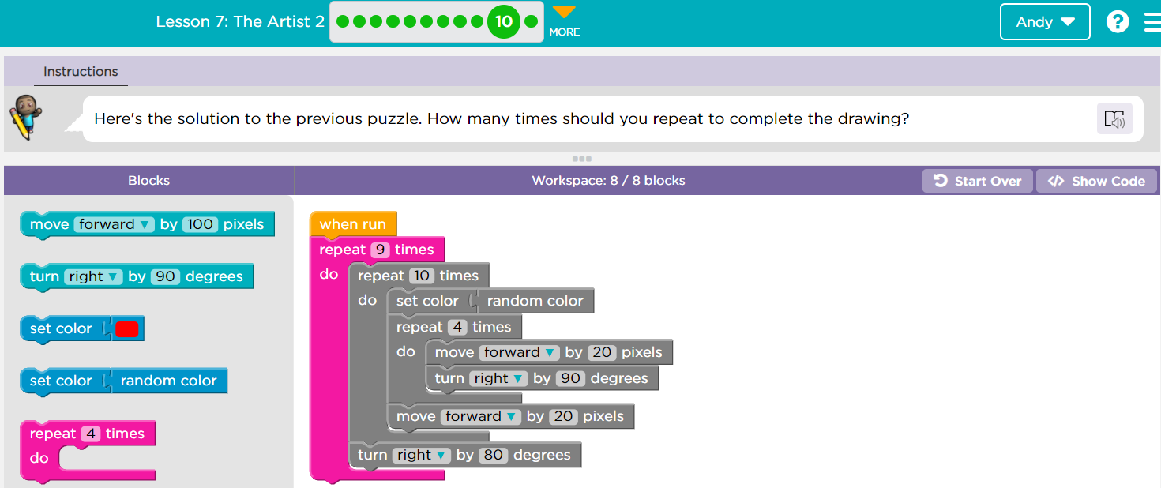

**Challenge 11: Draw this**

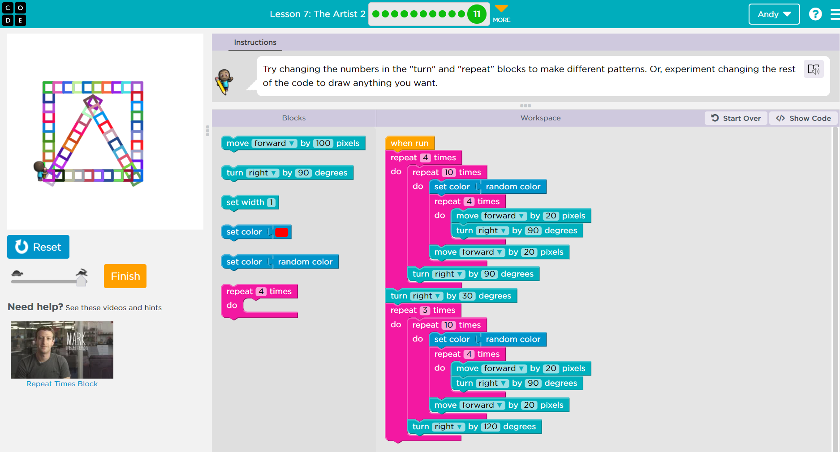

**Blockly Games: Turtle**

**Challenge 1**

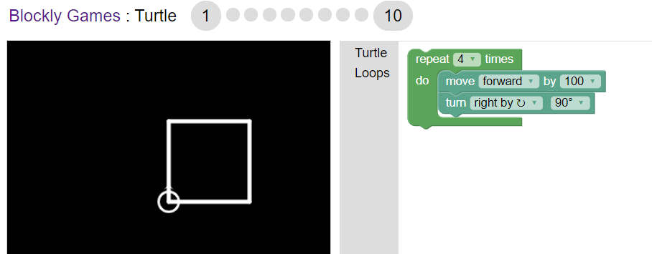

**Challenge 2**

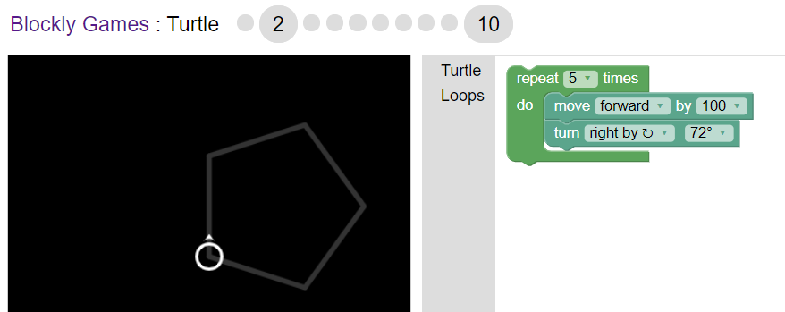

**Challenge 3**

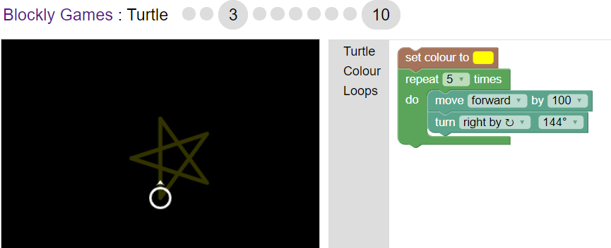

**Challenge 4**

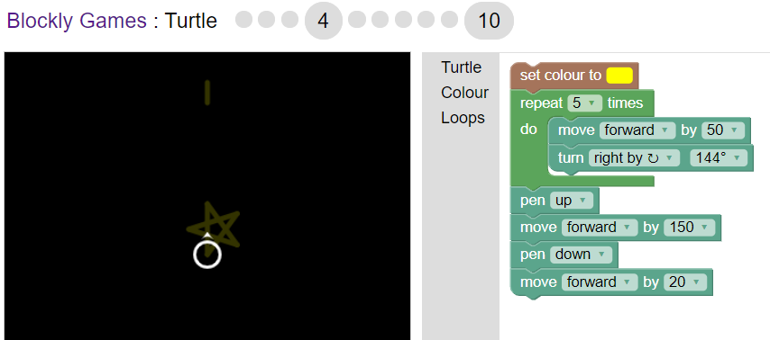

**Challenge 5**

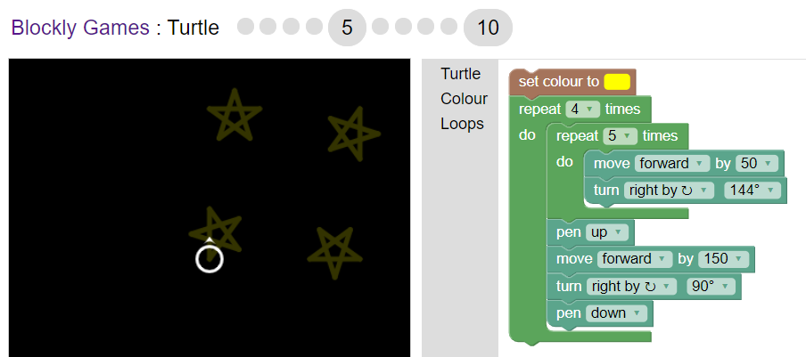

**Challenge 6**

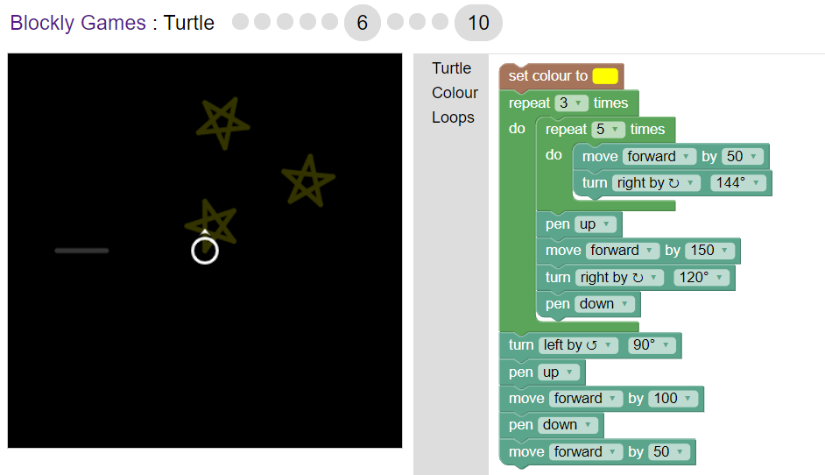

**Challenge 7**

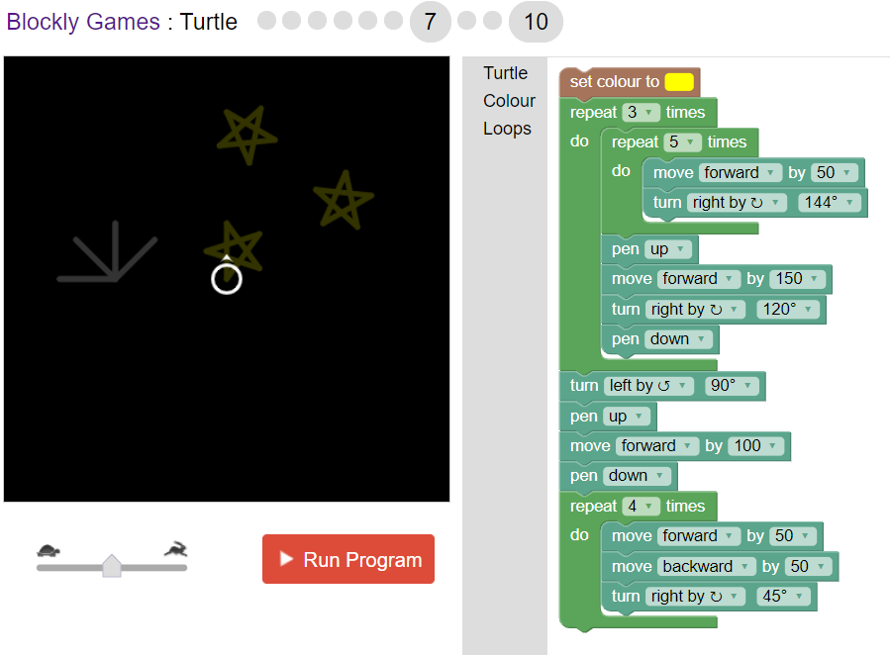

**Challenge 8**

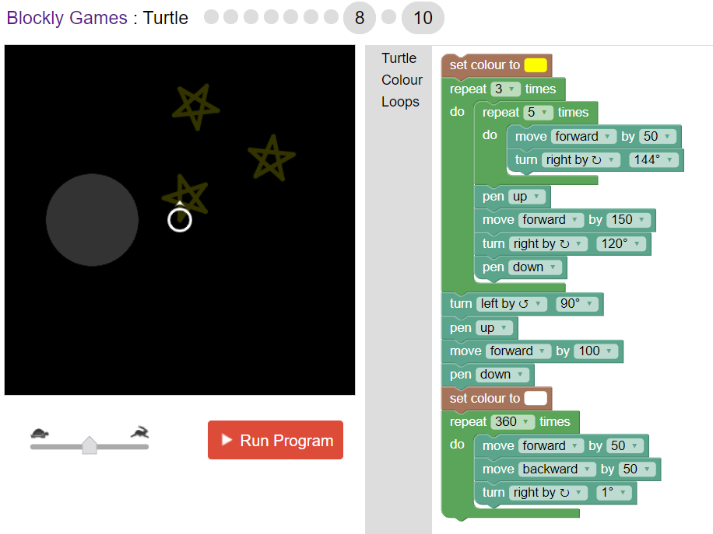

**Challenge 9**

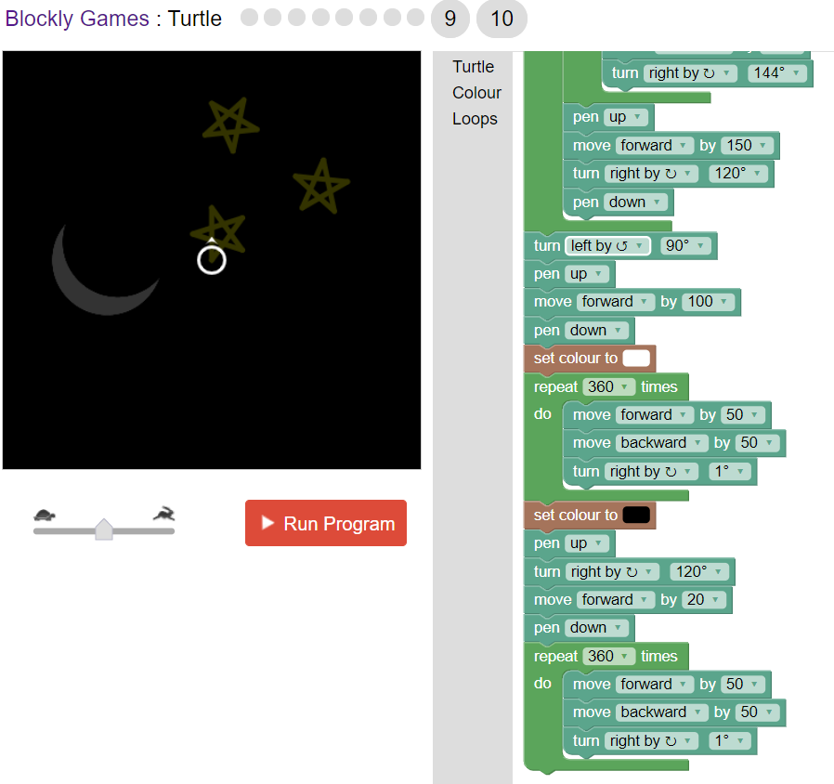

**Challenge 10: Draw a tennis ball**

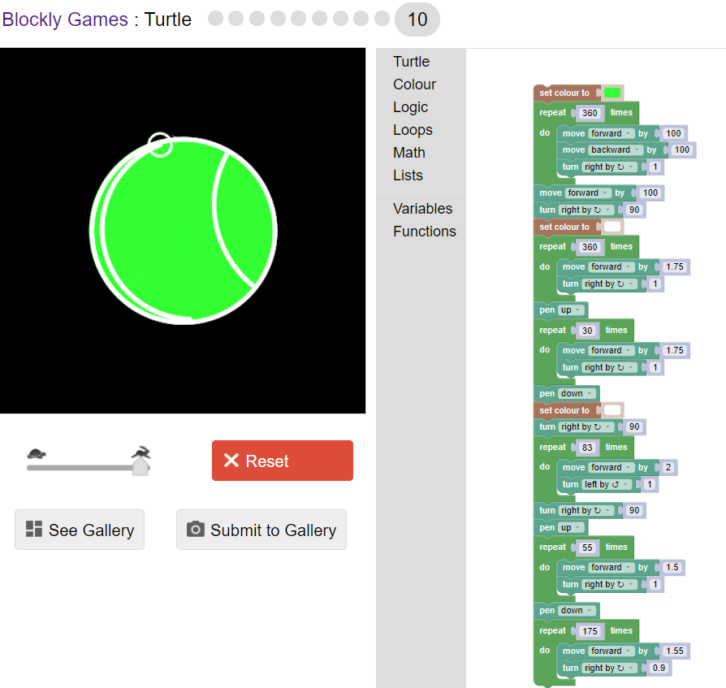

**Blockly Games: Movie**

**Challenge 1**

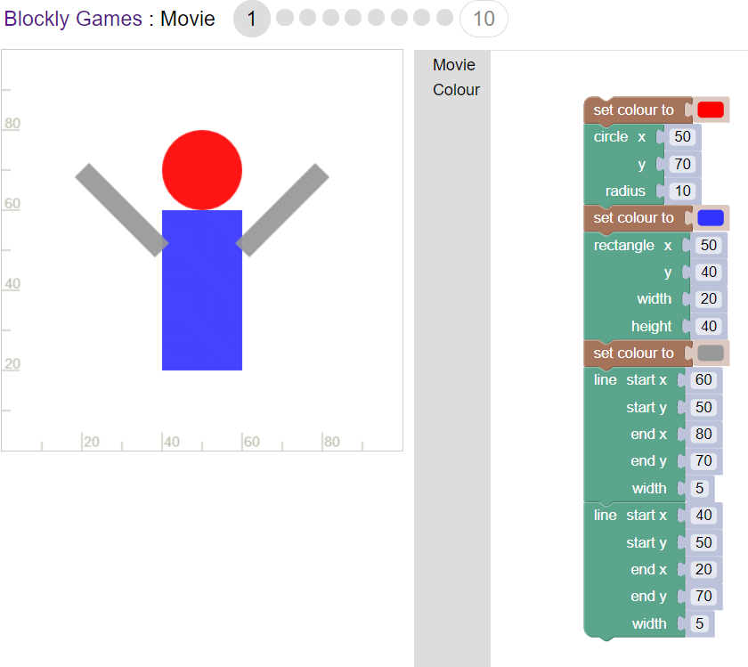

**Challenge 2**

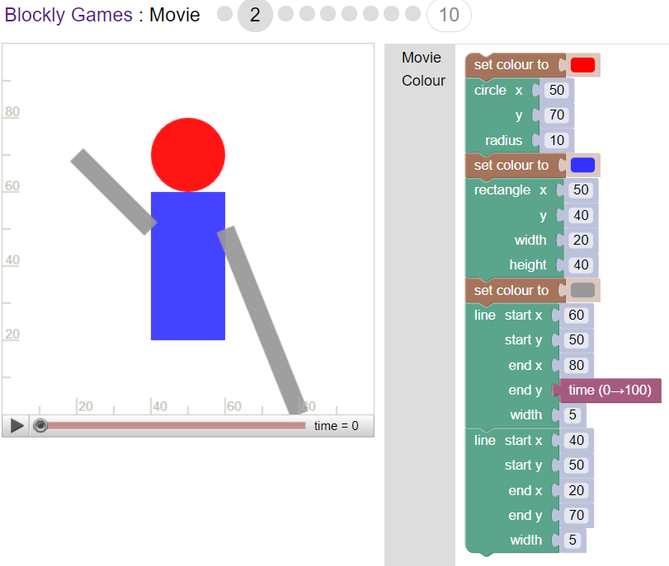

**Challenge 3**

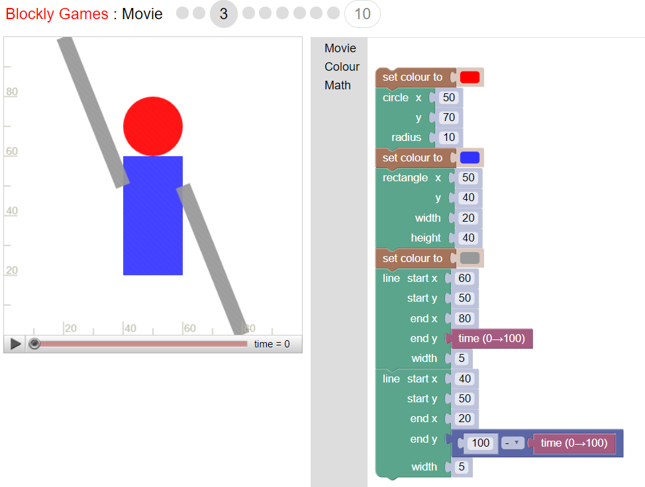

**Challenge 4**

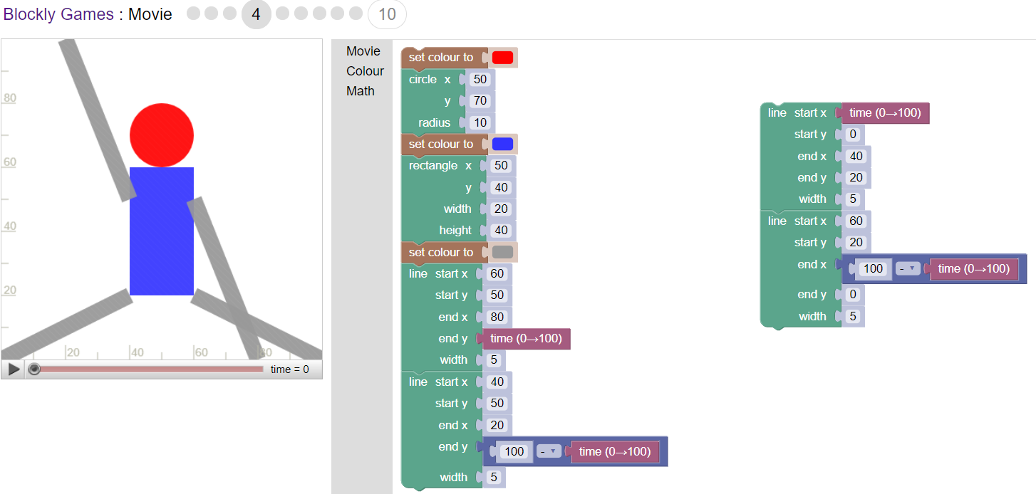

**Challenge 5**

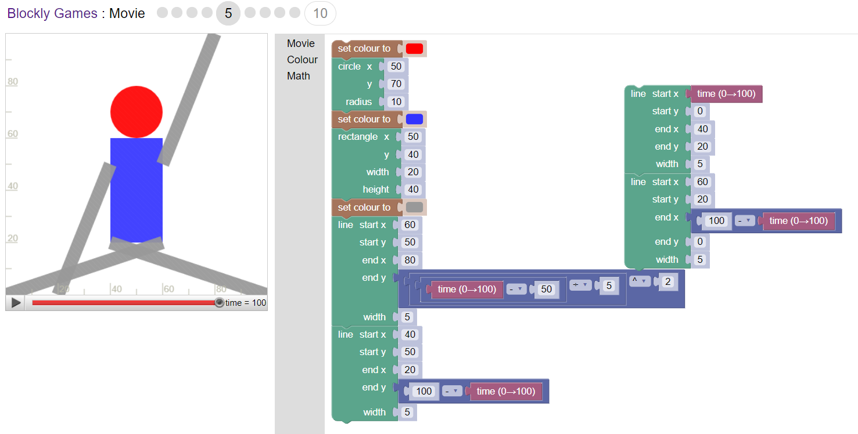

**Challenge 6**

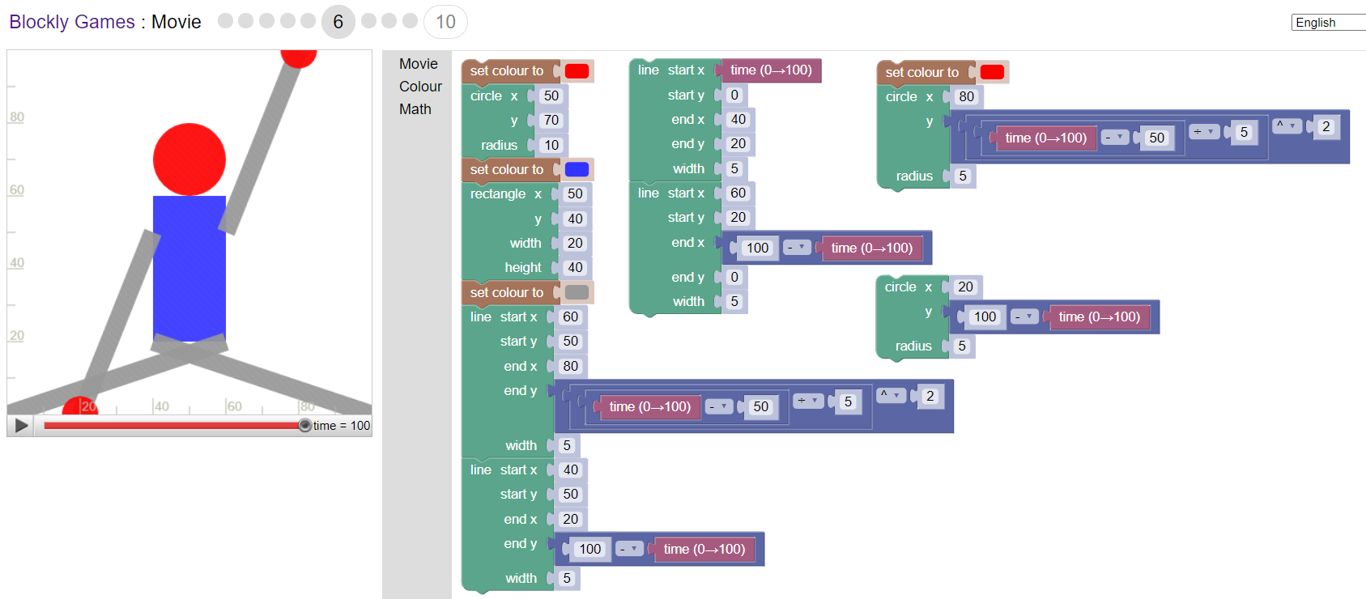

**Challenge 7**

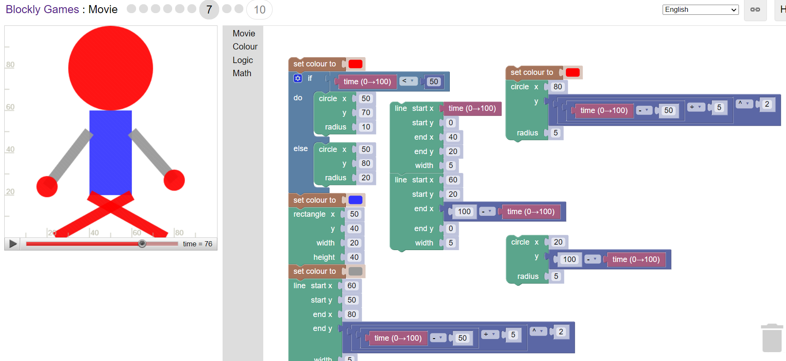

**Challenge 8**

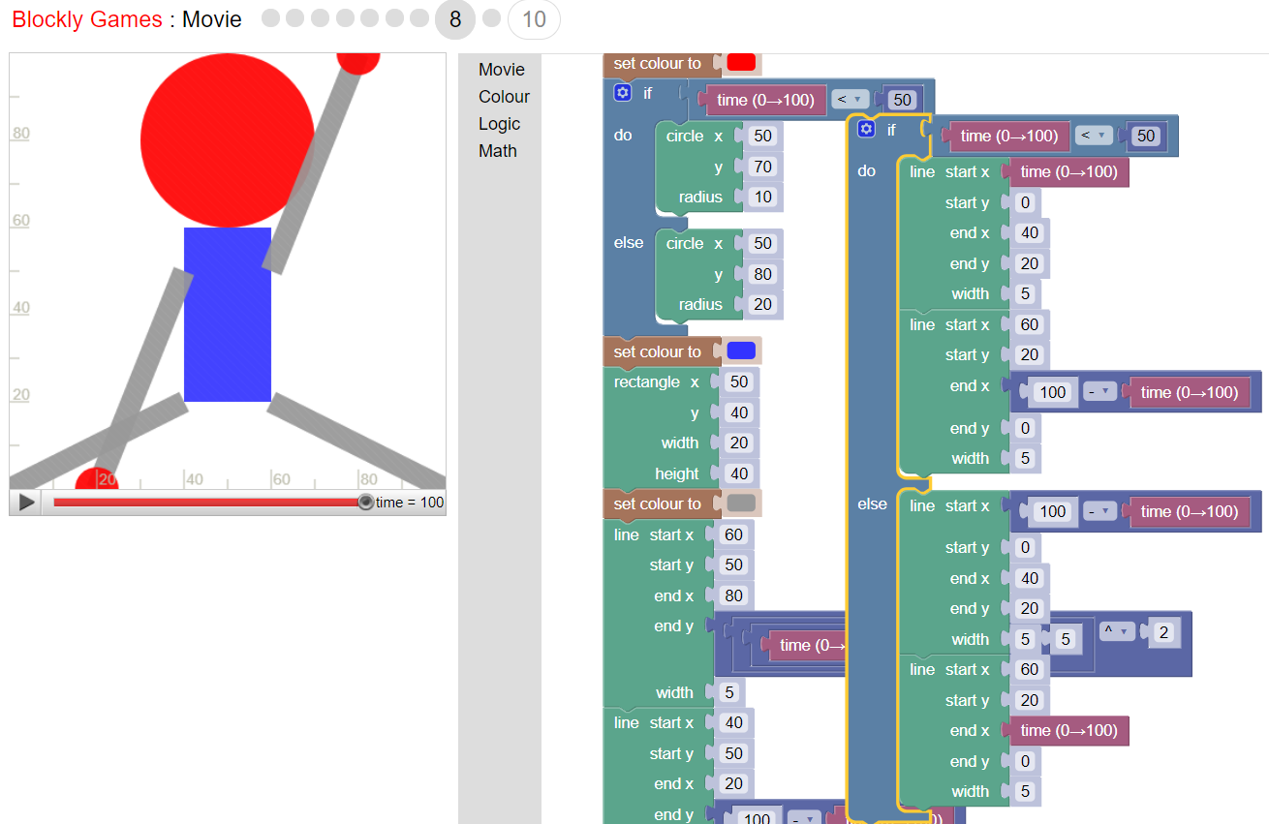

**Challenge 9**

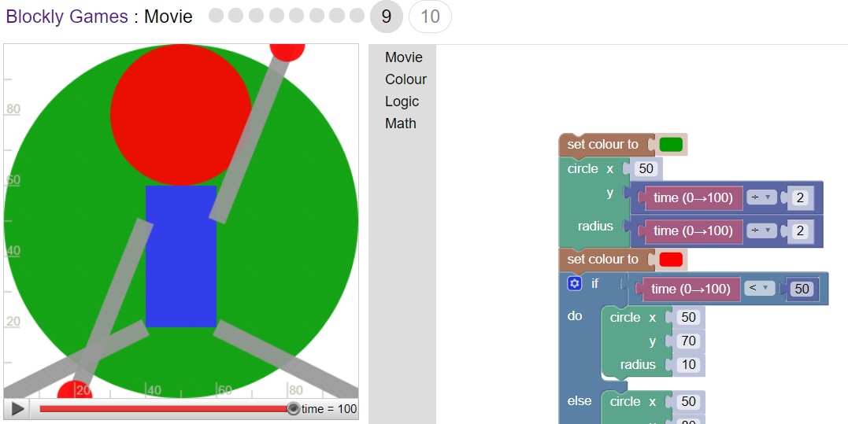

**Challenge 10: Draw four circles that will rotate to the circle left of it’s position**

